Module 6

COMPUTE

Topics

. Compute services overview

. Amazon EC2

. Amazon EC2 cost optimization

. Container services

. Introduction to AWS Lambda

. Introduction to AWS Elastic Beanstalk

1.Compute Services

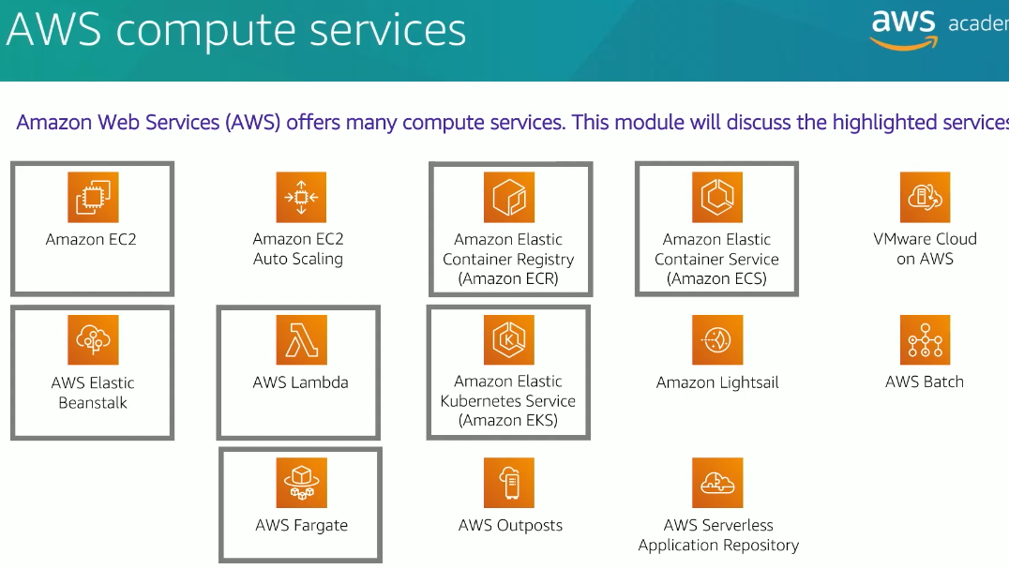

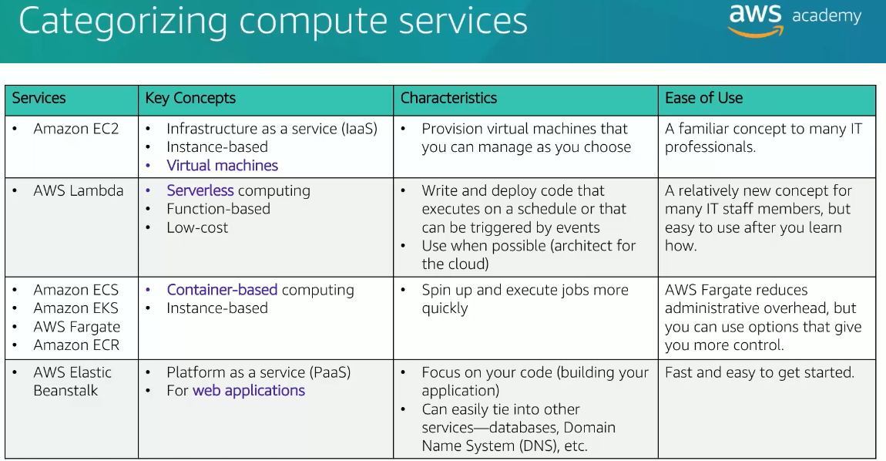

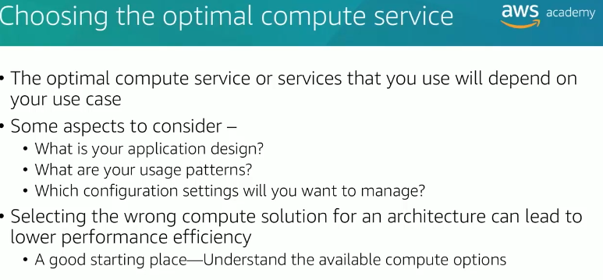

2.AMAZON EC2

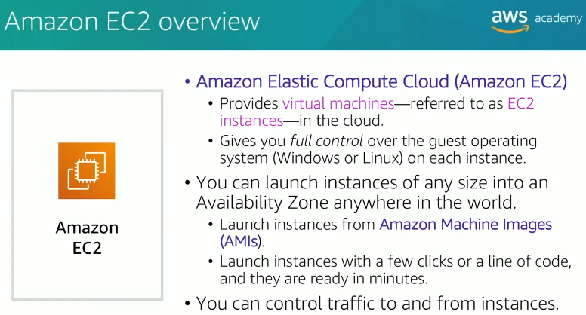

Nine Steps to consider while creating EC2 Instance

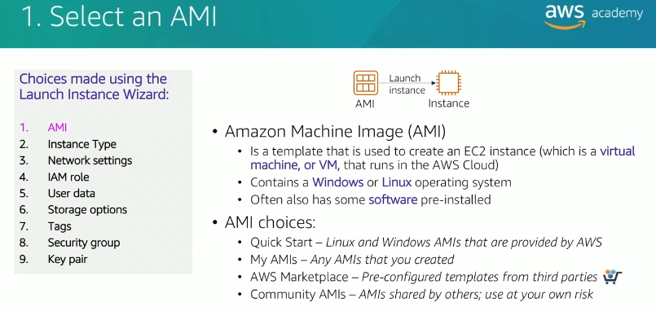

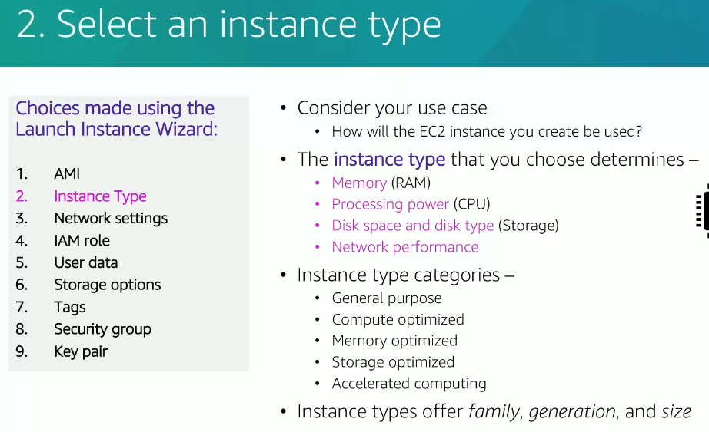

6. HPC Optimized – instance type category

**1. General Purpose:**

* **Use Case**: Balanced compute, memory, and networking resources.
* **Examples**: t4g (burstable), m6i, m5.
* **Ideal For**: Web servers, small databases, development environments.

**2. Compute Optimized:**

* **Use Case**: High-performance processors for compute-intensive tasks.
* **Examples**: c6i, c5.
* **Ideal For**: Batch processing, gaming servers, scientific modeling.

**3. Memory Optimized:**

* **Use Case**: High memory-to-CPU ratio for memory-intensive workloads.
* **Examples**: r6i, x1e, z1d.
* **Ideal For**: In-memory databases (e.g., Redis), real-time big data analytics.

**4. Storage Optimized:**

* **Use Case**: High-speed, low-latency storage for I/O-intensive workloads.
* **Examples**: i3, i4i, d3.
* **Ideal For**: NoSQL databases (e.g., Cassandra), data warehousing, log processing.

**5. Accelerated Computing:**

* **Use Case**: Hardware accelerators (e.g., GPUs, FPGAs) for specialized workloads.
* **Examples**: p4 (GPU), inf1 (Inferentia), f1 (FPGA).
* **Ideal For**: Machine learning, video transcoding, high-performance computing (HPC).

**6❌(not necessary). Burstable Performance:**

* **Use Case**: Baseline CPU performance with the ability to burst.
* **Examples**: t4g, t3.
* **Ideal For**: Applications with variable CPU usage (e.g., web apps, development environments).

**7. HPC Optimized:**

* **Use Case**: High-performance computing with low-latency networking.
* **Examples**: hpc6a.
* **Ideal For**: Complex simulations, financial modeling, genomics.

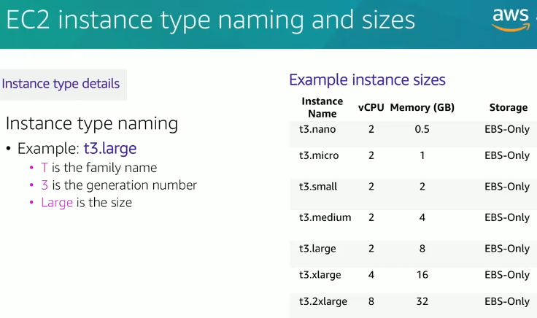 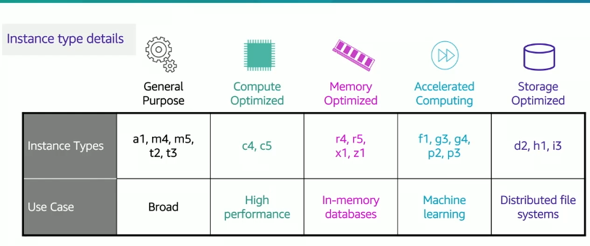

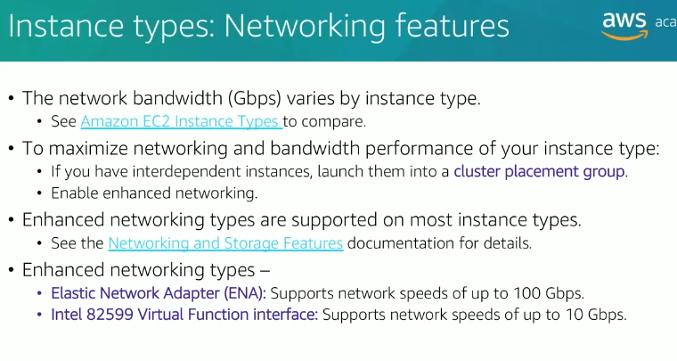

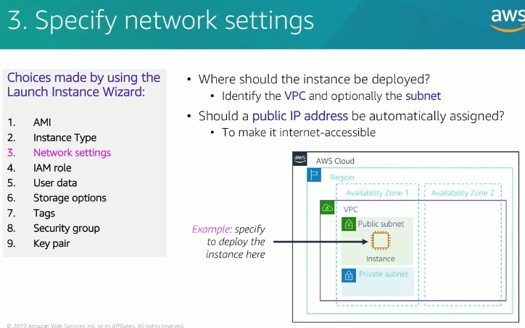

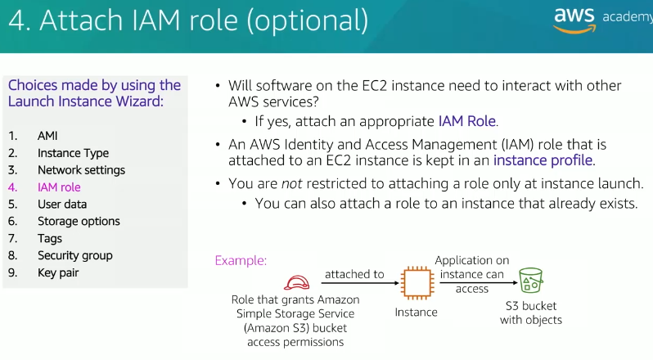

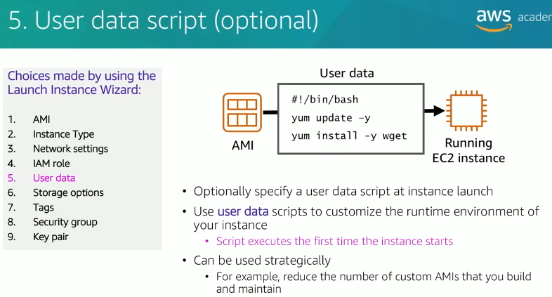

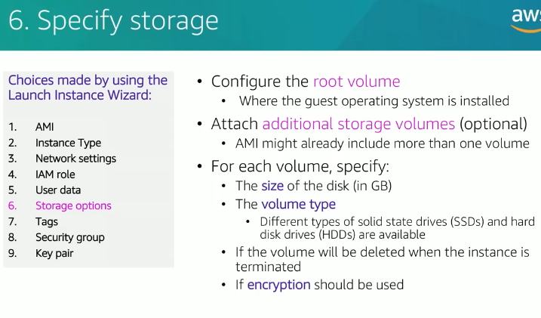

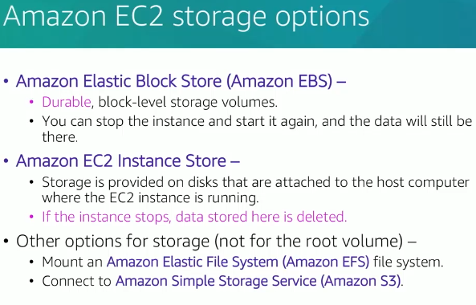

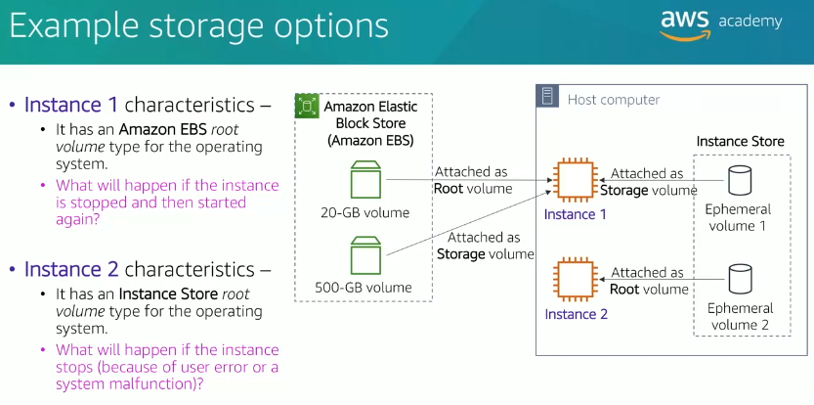

Part 3

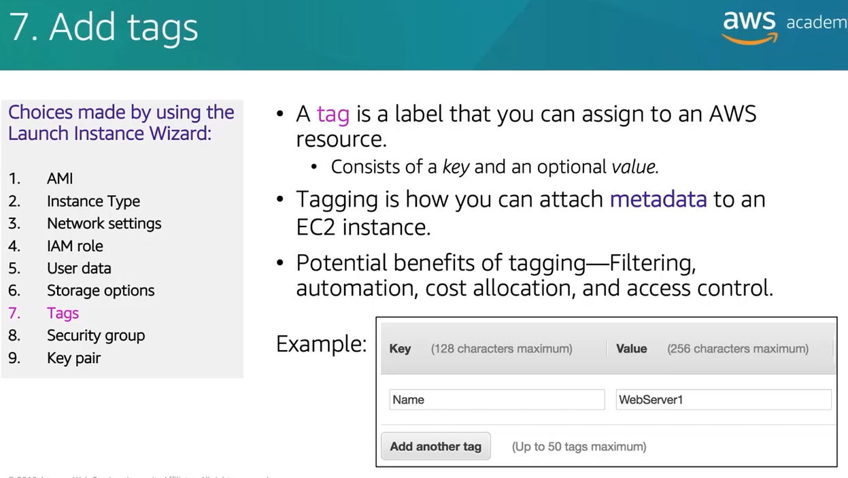

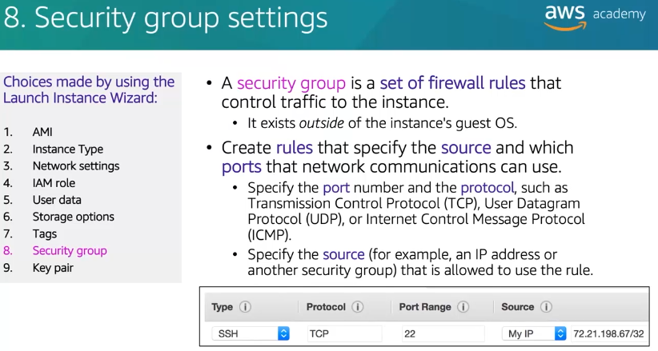

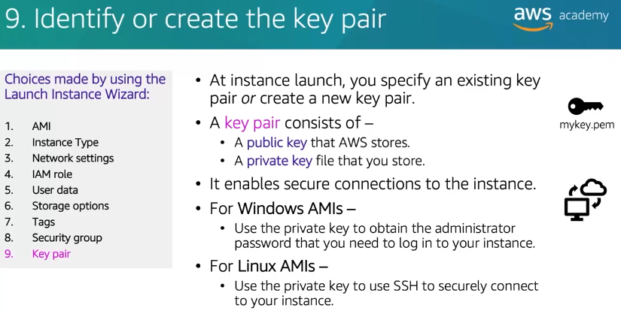

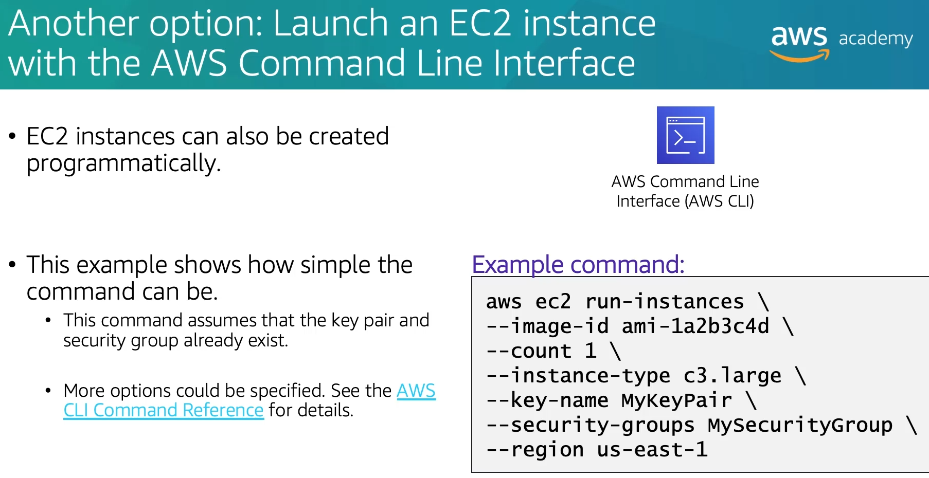

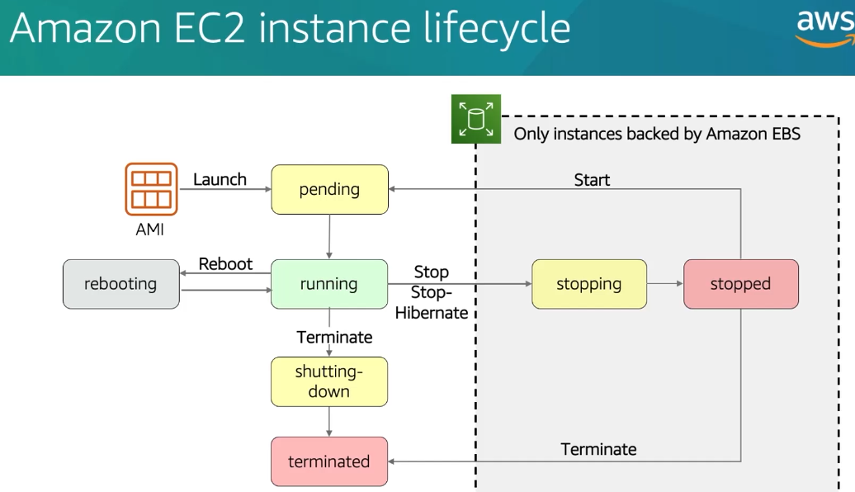

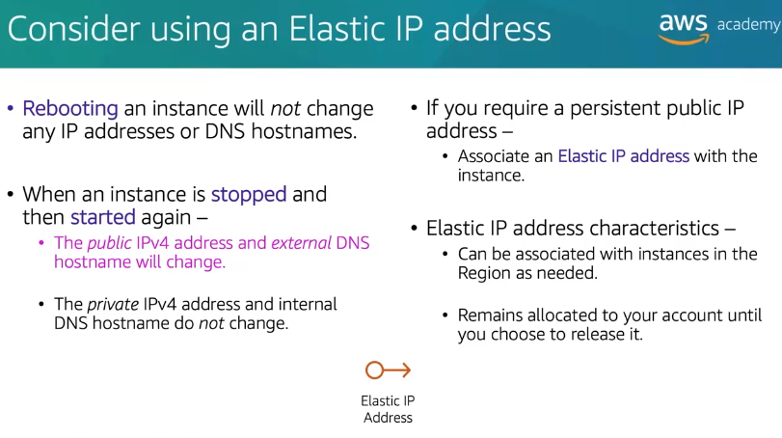



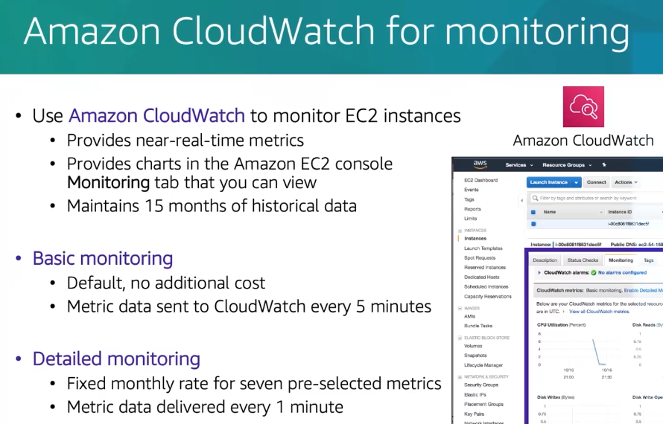

3.EC2 Cost Optimization

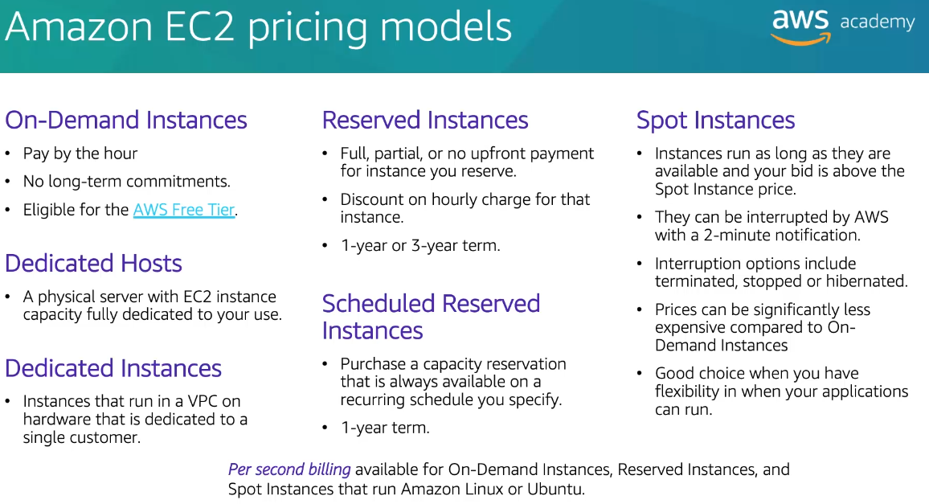

**1. On-Demand Instances**

* **Description**: Pay for compute capacity by the hour or second (minimum of 1 minute) with no long-term commitments.
* **Use Case**: Ideal for short-term workloads, unpredictable traffic, or applications being developed or tested.
* **Example**: Running a web application during a promotion.

**2. Reserved Instances (RI)**

* **Description**: Commit to using EC2 instances for 1 or 3 years in exchange for significant discounts (up to 75%) compared to On-Demand prices.
* **Types**:
  + **Standard Reserved Instances**: Deep discounts for steady-state workloads.
  + **Convertible Reserved Instances**: Flexible; allows exchanging for different instance types or sizes.
  + **Scheduled Reserved Instances**: For workloads that run on a regular schedule.
* **Use Case**: Best for steady-state or predictable usage (e.g., always-on databases).

**3. Savings Plans**

* **Description**: A flexible pricing model offering lower rates on EC2 and Fargate usage in exchange for a commitment to a consistent amount of usage (measured in $/hour) for 1 or 3 years.
* **Use Case**: Good for consistent workloads across different instance families, regions, or AWS services.

**4. Spot Instances**

* **Description**: Utilize unused EC2 capacity at discounts of up to 90% off On-Demand prices. Prices fluctuate based on supply and demand.
* **Use Case**: Suitable for fault-tolerant and flexible workloads like batch jobs, big data analysis, or CI/CD pipelines.
* **Risk**: Instances can be terminated if AWS needs the capacity back.

**5. Dedicated Hosts**

* **Description**: Physical servers fully dedicated to your use. You pay for the entire host.
* **Use Case**: Ideal for regulatory compliance or licensing that requires physical hardware separation.
* **Example**: Running legacy software that requires specific hardware.

**6. Dedicated Instances**

* **Description**: Instances that run on hardware dedicated to a single customer but priced based on instance usage, not the host.
* **Use Case**: Provides physical isolation for compliance needs.

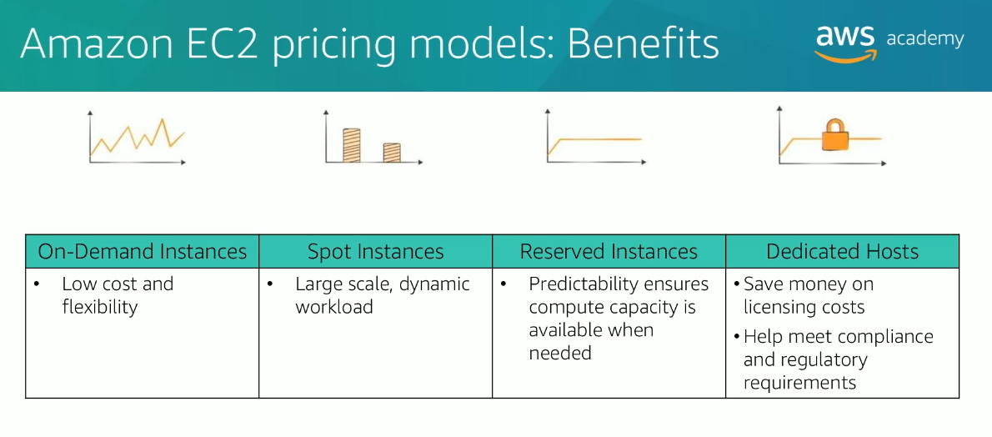

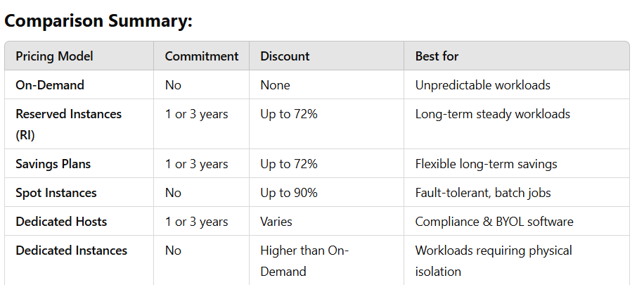

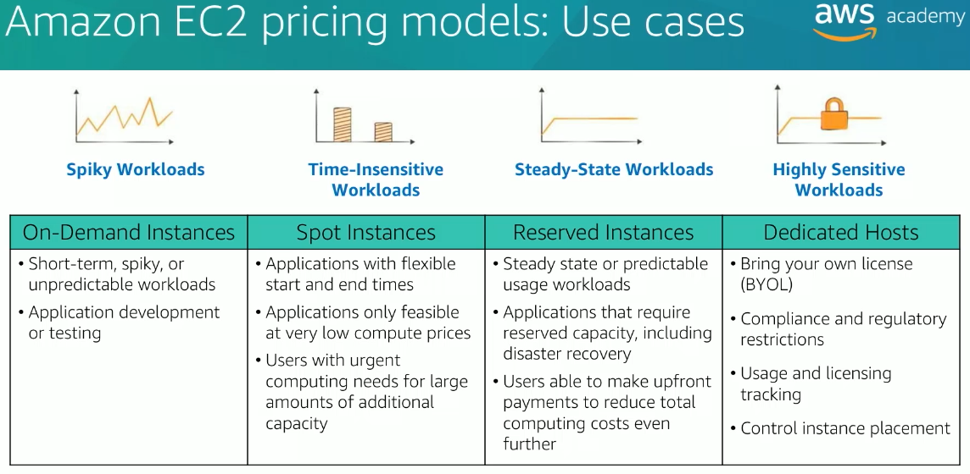

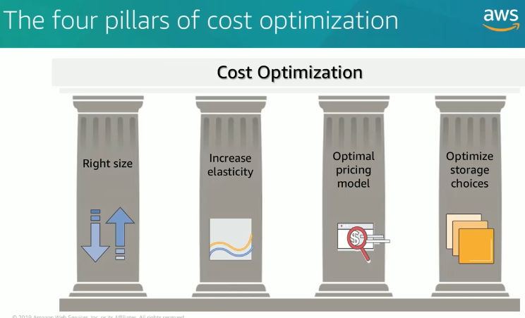

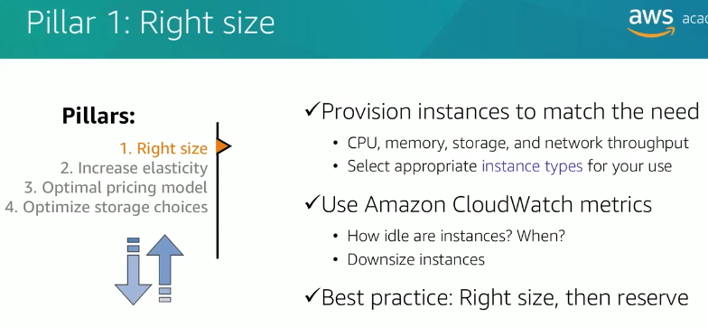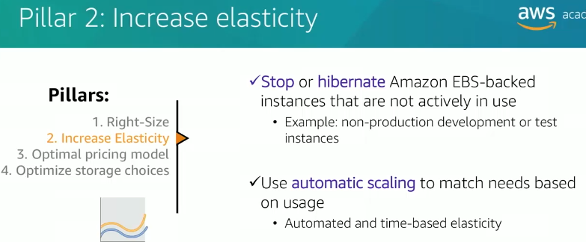

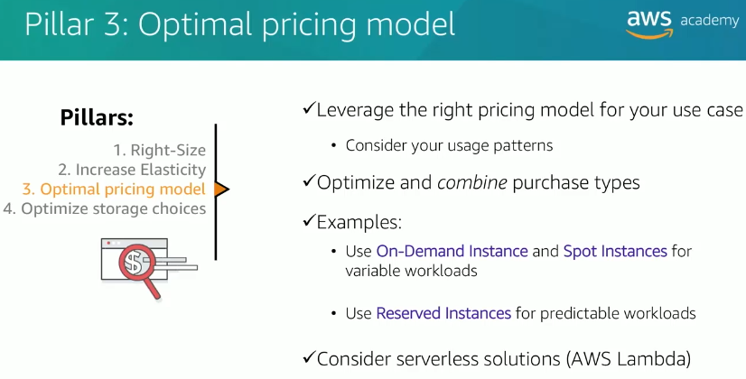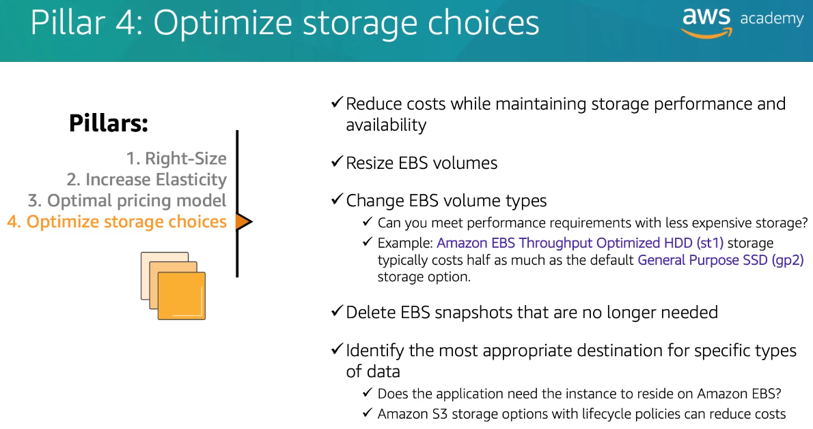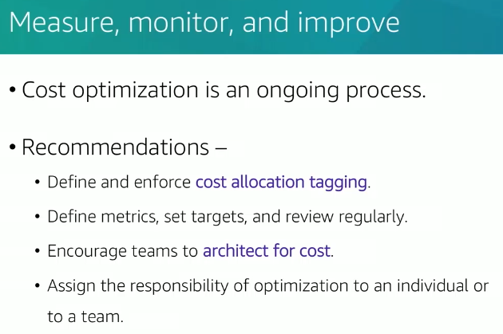

4.Container Services

**What is a Container?**

A **container** is a lightweight, portable, and self-contained unit that includes an application and all its dependencies (libraries, binaries, and configuration files) packaged together. Containers run consistently across different environments, whether it’s a developer’s local machine, a test environment, or a production server.

* **Key Features**:
  + **Isolation**: Containers isolate the application and its dependencies from the host system and other containers.
  + **Lightweight**: Containers share the host OS kernel, making them faster to start and less resource-intensive than virtual machines (VMs).
  + **Portability**: They work the same way across different systems (e.g., development, testing, production).
* **Examples**: Docker containers, Kubernetes Pods.

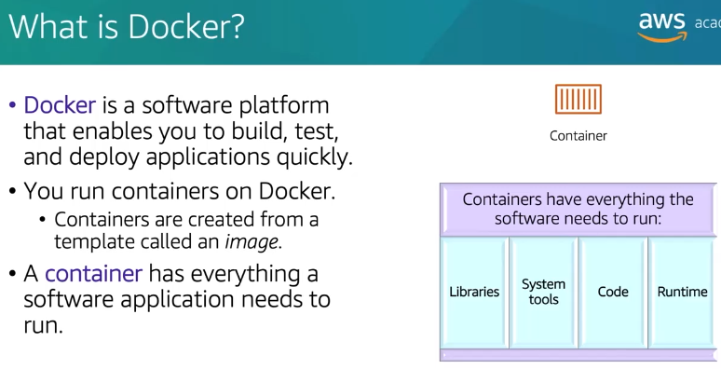

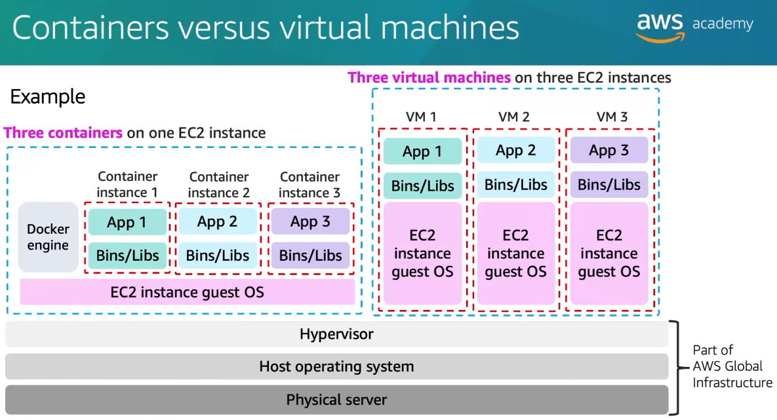

This diagram compares **containers** and **virtual machines (VMs)** on AWS, demonstrating their architectural differences when deployed on EC2 instances.

**Left Side: Containers**

* **Three Containers on One EC2 Instance**:
  + All containers share the **same EC2 instance guest OS** (operating system).
  + Each container is isolated and contains its own application (e.g., App 1, App 2, App 3) along with its required **binaries and libraries** (Bins/Libs).
  + The **Docker engine** (or another container runtime) runs on the EC2 instance and manages container creation, execution, and resource allocation.
  + **Advantages**:
    - Containers are lightweight because they share the OS kernel.
    - Efficient resource utilization since multiple containers can run on a single EC2 instance without requiring a separate OS for each application.

**Right Side: Virtual Machines (VMs)**

* **Three Virtual Machines on Three EC2 Instances**:
  + Each VM has its own copy of the **guest OS**, along with its **binaries, libraries**, and the application.
  + The **hypervisor** manages the virtualization layer, enabling multiple VMs to run on the same physical server.
  + Each VM is isolated from the others.
  + **Disadvantages**:
    - VMs are heavier than containers because each VM includes a full operating system.
    - Resource utilization is less efficient compared to containers, as each VM requires dedicated OS overhead.

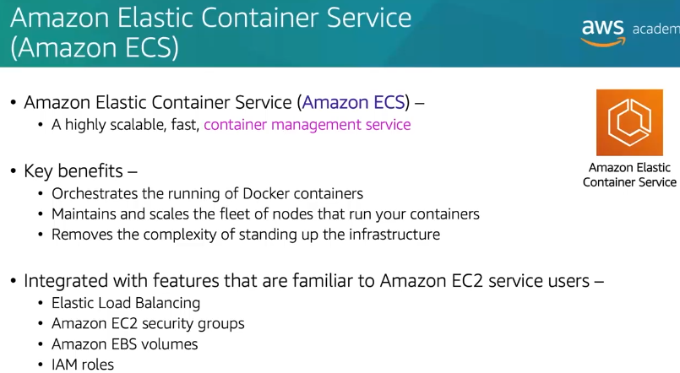

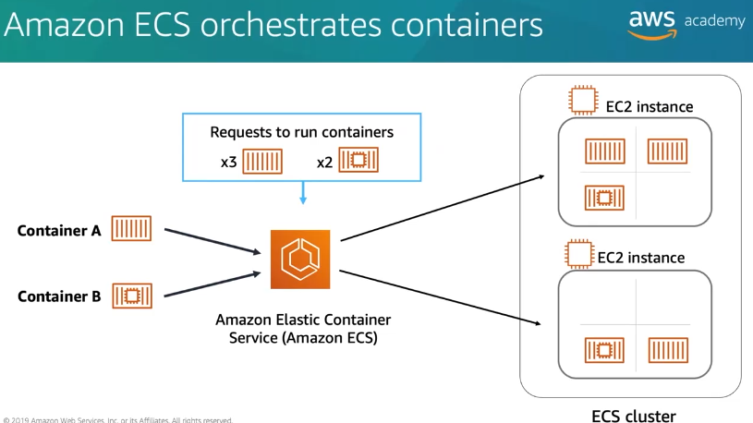

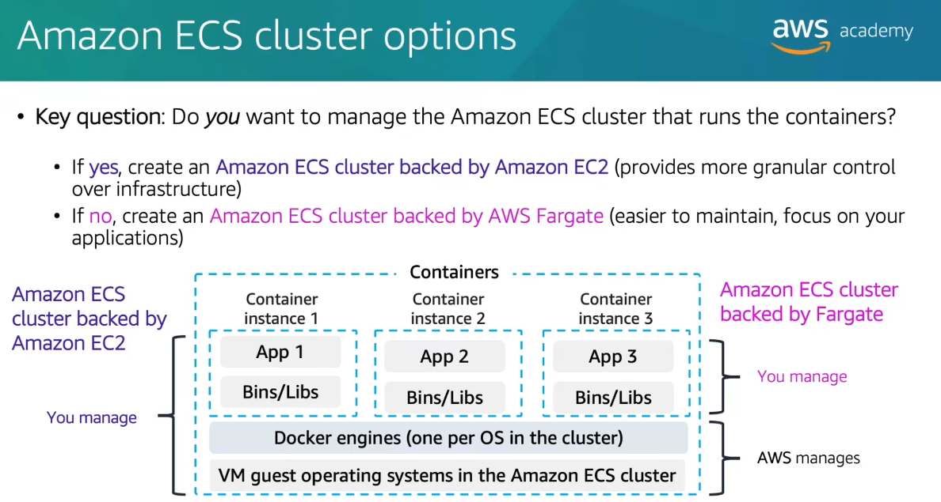

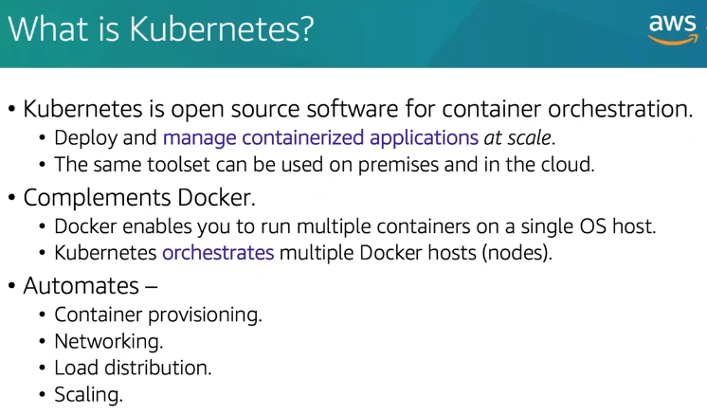

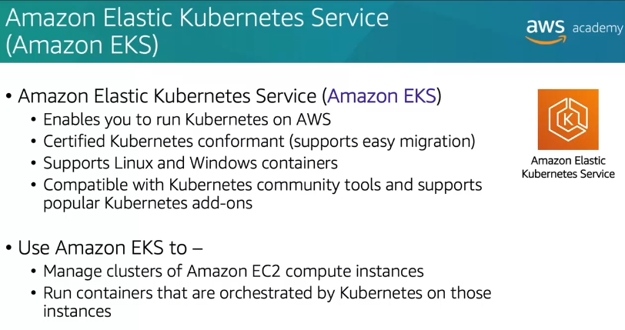

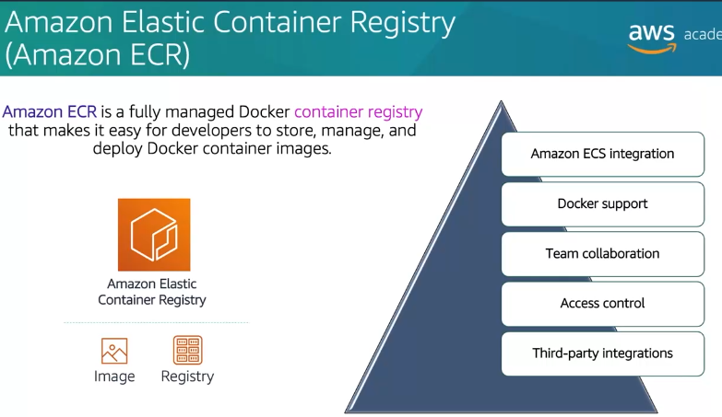

**Think of a Restaurant Analogy**

Imagine you’re running a restaurant. Here's how Docker, ECS, Kubernetes, and Fargate fit into the picture:

1. **Docker**:
   * It’s like the **kitchen staff** who prepare and package the food.
   * It’s responsible for creating and running **containers** (small, lightweight packages that include everything needed to run your application, like the ingredients and recipe for a dish).
2. **Amazon ECS (Elastic Container Service)**:
   * ECS is like a **restaurant manager** who tells the kitchen staff (Docker) which dishes to prepare, when, and how many.
   * It’s a **container orchestration tool** that manages the deployment and scaling of containers. It works specifically with AWS infrastructure.

**1. What is Amazon ECS?**

* **Amazon ECS** is a fully managed **container orchestration service** that allows you to run, scale, and manage **Docker containers** on AWS.
* It is used to deploy and manage containerized applications.

**2. Key Use Cases for ECS**

* Running **microservices**.
* Deploying **web applications**.
* Executing **batch processing** jobs.
* Running **CI/CD pipelines**.
* Deploying **machine learning models** for inference.

**3. Core Components of ECS**

* **Cluster**: A logical grouping of resources (EC2 instances or Fargate capacity) where containers run.
* **Task Definition**: A blueprint for your application that defines the Docker image, CPU, memory, and other settings.
* **Task**: An instance of a task definition (a running container or group of containers).
* **Service**: A long-running application that maintains a specified number of tasks (e.g., a web server).

**4. Launch Types**

* **EC2 Launch Type**:
  + You manage the underlying EC2 instances.
  + You have full control over the infrastructure.
* **Fargate Launch Type**:
  + **Serverless**: AWS manages the infrastructure.
  + You only pay for the vCPU and memory used by your containers.

**5. Key Features of ECS**

* **Integration with AWS Services**:
  + Works seamlessly with **ALB (Application Load Balancer)**, **CloudWatch**, **IAM**, and **VPC**.
* **Auto Scaling**:
  + Automatically scales the number of tasks based on demand.
* **Service Discovery**:
  + Automatically registers and discovers services using **AWS Cloud Map**.
* **Security**:
  + Uses **IAM roles** for tasks to grant permissions.
  + Integrates with **Secrets Manager** for secure storage of sensitive information.

**6. Benefits of ECS**

* **Fully Managed**: AWS handles the underlying infrastructure.
* **Scalable**: Automatically scales applications based on demand.
* **Cost-Effective**: Pay only for the resources you use (especially with Fargate).
* **Secure**: Integrates with IAM, VPC, and Secrets Manager for robust security.

**7. ECS vs. Other AWS Services**

* **ECS vs. EKS**:
  + ECS is AWS's proprietary container orchestration service.
  + EKS is a managed Kubernetes service (open-source).
* **ECS vs. Lambda**:
  + ECS runs containers for long-running applications.
  + Lambda runs short-lived, event-driven functions (serverless).

**8. Pricing**

* **EC2 Launch Type**:
  + Pay for the EC2 instances you use.
* **Fargate Launch Type**:
  + Pay for the vCPU and memory used by your tasks (billed per second).
* Additional costs may include:
  + Load balancer usage.
  + CloudWatch logs and metrics.
  + ECR (Elastic Container Registry) for storing Docker images.

**9. Key Terms to Remember**

* **Cluster**: Group of resources for running containers.
* **Task Definition**: Blueprint for your application.
* **Task**: Running instance of a task definition.
* **Service**: Long-running application with multiple tasks.
* **Fargate**: Serverless compute engine for containers.

**10. Exam Tips**

* Focus on understanding **what ECS is used for** (running containers) and its **key features** (scaling, integration with AWS services, etc.).
* Know the difference between **EC2 launch type** and **Fargate launch type**.
* Remember that ECS is a **fully managed service**, meaning AWS handles the underlying infrastructure.
* Be familiar with the **benefits of ECS**, such as scalability, cost-effectiveness, and security.

**Sample Exam Questions**

1. **What is Amazon ECS used for?**
   * A) Running virtual machines.
   * B) Running Docker containers.
   * C) Storing object data.
   * **Answer**: B) Running Docker containers.
2. **Which launch type in ECS allows you to run containers without managing EC2 instances?**
   * A) EC2 Launch Type.
   * B) Fargate Launch Type.
   * C) Lambda Launch Type.
   * **Answer**: B) Fargate Launch Type.
3. **Which AWS service integrates with ECS for load balancing?**
   * A) Amazon S3.
   * B) Amazon RDS.
   * C) Application Load Balancer (ALB).
   * **Answer**: C) Application Load Balancer (ALB).
4. **Kubernetes**:
   * Kubernetes is like a **franchise manager** running multiple restaurants, ensuring all branches are consistent, well-staffed, and handling customers efficiently.
   * It’s a **container orchestration tool** like ECS but works across multiple environments (AWS, Google Cloud, on-premises). It’s more complex but more powerful for large, distributed systems.

**1. What is Kubernetes?**

* Kubernetes is an **open-source container orchestration platform** used to automate the deployment, scaling, and management of containerized applications.
* It is widely used for running **microservices** and **distributed applications**.

**2. What is Amazon EKS?**

* **Amazon EKS (Elastic Kubernetes Service)** is a **fully managed Kubernetes service** provided by AWS.
* It allows you to run Kubernetes on AWS without needing to install, operate, or maintain your own Kubernetes control plane.

**3. Key Features of EKS**

* **Managed Control Plane**: AWS manages the Kubernetes control plane (e.g., API server, etcd).
* **Integration with AWS Services**: Works seamlessly with services like **IAM**, **VPC**, **CloudWatch**, and **Load Balancers**.
* **Scalability**: Automatically scales applications based on demand.
* **Security**: Integrates with IAM for access control and supports network isolation using VPC.

**4. Key Components of Kubernetes**

* **Cluster**: A group of nodes (servers) that run containerized applications.
* **Node**: A worker machine (virtual or physical) that runs containers.
* **Pod**: The smallest deployable unit in Kubernetes, which can contain one or more containers.
* **Deployment**: A declarative way to manage Pods and ReplicaSets (ensures a specified number of Pods are running).
* **Service**: An abstraction that defines a logical set of Pods and a policy to access them (e.g., load balancing).

**5. EKS Use Cases**

* Running **microservices**.
* Deploying **scalable web applications**.
* Managing **machine learning workloads**.
* Running **hybrid cloud applications** (on-premises and cloud).

**6. Benefits of EKS**

* **Fully Managed**: AWS manages the Kubernetes control plane.
* **Scalable**: Automatically scales applications based on demand.
* **Secure**: Integrates with IAM and VPC for robust security.
* **Portable**: Kubernetes is cloud-agnostic, so you can move workloads to other clouds or on-premises.

**7. EKS vs. ECS**

* **EKS**:
  + Uses **Kubernetes** (open-source).
  + More complex but highly customizable.
  + Ideal for multi-cloud or hybrid cloud environments.
* **ECS**:
  + AWS's proprietary container orchestration service.
  + Easier to use and tightly integrated with AWS services.
  + Ideal for AWS-only environments.

**8. Pricing**

* **EKS Control Plane**: You pay $0.10 per hour per cluster (as of 2023).
* **Worker Nodes**: You pay for the EC2 instances or Fargate capacity used to run your containers.
* Additional costs may include:
  + Load balancer usage.
  + CloudWatch logs and metrics.
  + ECR (Elastic Container Registry) for storing Docker images.

**9. Key Terms to Remember**

* **Kubernetes**: Open-source container orchestration platform.
* **EKS**: AWS's managed Kubernetes service.
* **Cluster**: Group of nodes running containerized applications.
* **Pod**: Smallest deployable unit in Kubernetes.
* **Node**: Worker machine that runs containers.

**10. Exam Tips**

* Focus on understanding **what Kubernetes and EKS are used for** (running and managing containerized applications).
* Know that **EKS is a managed Kubernetes service** provided by AWS.
* Understand the **key benefits of EKS**, such as scalability, security, and integration with AWS services.
* Be familiar with the **difference between EKS and ECS**:
  + EKS uses Kubernetes (open-source).
  + ECS is AWS's proprietary container orchestration service.

**Sample Exam Questions**

1. **What is Amazon EKS used for?**
   * A) Running virtual machines.
   * B) Running Kubernetes applications.
   * C) Storing object data.
   * **Answer**: B) Running Kubernetes applications.
2. **Which AWS service is used to run managed Kubernetes clusters?**
   * A) Amazon ECS.
   * B) Amazon EKS.
   * C) AWS Lambda.
   * **Answer**: B) Amazon EKS.
3. **What is a Pod in Kubernetes?**
   * A) A group of containers.
   * B) A virtual machine.
   * C) A load balancer.
   * **Answer**: A) A group of containers.
4. **AWS Fargate**:

**1. What is AWS Fargate?**

* **AWS Fargate** is a **serverless compute engine** for containers.
* It works with **Amazon ECS (Elastic Container Service)** and **Amazon EKS (Elastic Kubernetes Service)** to run containers without needing to manage the underlying infrastructure (e.g., EC2 instances).

**2. Key Features of Fargate**

* **Serverless**: No need to provision or manage EC2 instances.
* **Pay-as-You-Go**: Pay only for the vCPU and memory used by your containers (billed per second).
* **Automatic Scaling**: Automatically scales to match the demand of your containers.
* **Security**: Each task or pod runs in its own isolated environment.

**3. How Fargate Works**

* **With ECS**: Fargate allows you to run ECS tasks without managing EC2 instances.
* **With EKS**: Fargate allows you to run Kubernetes pods without managing worker nodes.

**4. Benefits of Fargate**

* **Simplified Operations**: No need to manage servers (EC2 instances or worker nodes).
* **Cost-Effective**: Pay only for the resources you use.
* **Scalable**: Automatically scales to handle changes in demand.
* **Secure**: Provides strong isolation between tasks or pods.

**5. Use Cases for Fargate**

* **Short-Lived Tasks**: Ideal for batch jobs or tasks that don’t require persistent infrastructure.
* **Microservices**: Simplifies running microservices by eliminating the need to manage infrastructure.
* **Development and Testing**: Great for development and testing environments where you don’t want to manage infrastructure.
* **Applications with Variable Workloads**: Automatically scales to handle variable workloads.

**6. Fargate vs. EC2 Launch Type**

* **Fargate**:
  + Serverless: No need to manage EC2 instances.
  + Pay for vCPU and memory used by containers.
  + Automatically scales infrastructure.
* **EC2 Launch Type**:
  + You manage the EC2 instances.
  + Pay for the entire EC2 instance (even if underutilized).
  + You need to manually scale the infrastructure.

**7. Pricing**

* **Fargate Pricing**:
  + Pay for the vCPU and memory used by your tasks or pods.
  + Billed per second with a 1-minute minimum.
* **Additional Costs**:
  + Load balancer usage.
  + CloudWatch logs and metrics.
  + ECR (Elastic Container Registry) for storing Docker images.

**8. Key Terms to Remember**

* **Fargate**: Serverless compute engine for containers.
* **Task**: An instance of a task definition (a running container or group of containers).
* **Pod**: The smallest deployable unit in Kubernetes (can contain one or more containers).

**9. Exam Tips**

* Focus on understanding **what Fargate is used for** (running containers without managing servers).
* Know that Fargate is **serverless** and **pay-as-you-go**.
* Understand the **benefits of Fargate**, such as simplified operations, cost-effectiveness, and scalability.
* Be familiar with the **difference between Fargate and EC2 launch type**:
  + Fargate: No need to manage EC2 instances.
  + EC2 Launch Type: You manage the EC2 instances.

**Sample Exam Questions**

1. **What is AWS Fargate used for?**
   * A) Running virtual machines.
   * B) Running containers without managing servers.
   * C) Storing object data.
   * **Answer**: B) Running containers without managing servers.
2. **Which AWS service allows you to run containers without managing EC2 instances?**
   * A) Amazon ECS.
   * B) AWS Fargate.
   * C) AWS Lambda.
   * **Answer**: B) AWS Fargate.
3. **What is the pricing model for AWS Fargate?**
   * A) Pay for the entire EC2 instance.
   * B) Pay for the vCPU and memory used by containers.
   * C) Pay for the number of containers.
   * **Answer**: B) Pay for the vCPU and memory used by containers.

By focusing on these key points, you’ll be well-prepared to answer any Fargate-related questions on the **AWS Cloud Practitioner Exam**. Good luck! 🚀

**Breaking Down Each Concept**

**1. Docker:**

* **What it does**: Creates and runs containers.
* **Key feature**: It’s lightweight and portable. You can run a container on your laptop, in AWS, or anywhere.
* **Example**: You create a container with your app and all its dependencies. Think of it as a "ready-to-eat meal in a box."

**2. Amazon ECS:**

* **What it does**: Manages the deployment of your Docker containers on AWS infrastructure.
* **Key feature**: It’s AWS-native and works well with other AWS services like IAM, CloudWatch, and ELB.
* **Example**: ECS decides how many containers to run (scaling) and which EC2 instances (servers) to run them on. Think of it as a manager assigning jobs to staff in your restaurant.

**3. Kubernetes:**

* **What it does**: Like ECS, it manages and orchestrates containers, but it’s more flexible and not tied to AWS.
* **Key feature**: Works across multiple cloud providers and even on-premises systems.
* **Example**: If your business operates across multiple locations (AWS, Google Cloud, or even on your own servers), Kubernetes ensures consistency across all locations. It handles scaling, load balancing, and failover.

**4. AWS Fargate:**

* **What it does**: Runs your Docker containers without you managing the servers.
* **Key feature**: Serverless—AWS takes care of the infrastructure, so you only focus on the containers.
* **Example**: Instead of buying and managing delivery trucks (servers), you just tell AWS how many containers to run, and Fargate handles the rest.

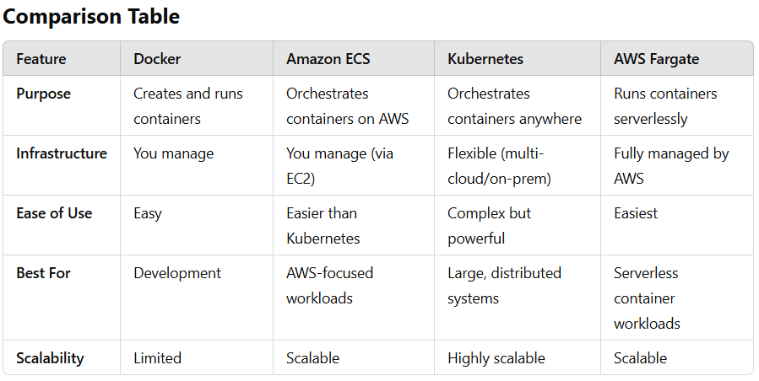

**When to Use What**

1. **Docker**:
   * Use when you want to create portable containers during development.
   * Example: You’re building an app on your laptop and want it to run the same way in production.
2. **Amazon ECS**:
   * Use when you’re all-in on AWS and want an easy way to manage and scale your containers.
   * Example: Running a microservices app on AWS with EC2 instances.
3. **Kubernetes**:
   * Use when you need advanced orchestration across multiple clouds or hybrid environments.
   * Example: Managing a global app that needs to run on AWS, Google Cloud, and on-premises servers.
4. **AWS Fargate**:
   * Use when you don’t want to manage servers at all and prefer a serverless container solution.
   * Example: Running short-lived tasks like batch processing or event-driven apps.

**Quick Analogy Recap**

* **Docker**: The kitchen staff (prepares containers).
* **ECS**: The restaurant manager (deploys containers on AWS).
* **Kubernetes**: The franchise manager (handles multi-location setups).
* **Fargate**: The delivery service (runs containers without worrying about servers).

**Amazon ECR (Elastic Container Registry)**

**Amazon Elastic Container Registry (ECR)** is a fully managed **container image registry** provided by AWS. It simplifies the process of **storing**, **managing**, and **deploying Docker container images**. Think of it as a private storage service specifically designed for your container images.

**What Does ECR Do?**

When you work with containers, you need a place to store the container images (the "blueprints" of your containers). ECR acts as this storage, ensuring your images are:

1. **Securely Stored**: All images are encrypted at rest and during transit.
2. **Easily Accessible**: Fully integrated with AWS services like ECS, EKS, and Fargate.
3. **Highly Available**: Images are stored in a highly available and scalable environment.

**5.AWS Lambda**

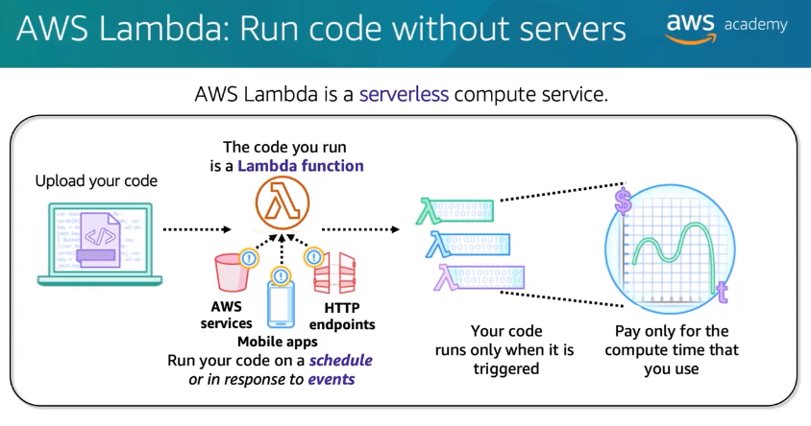

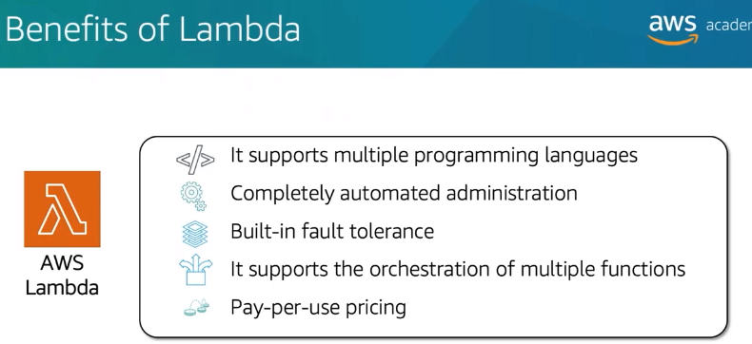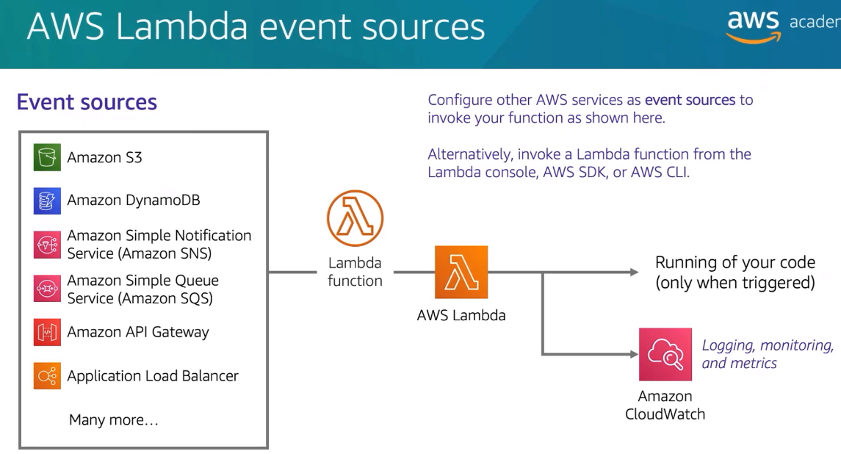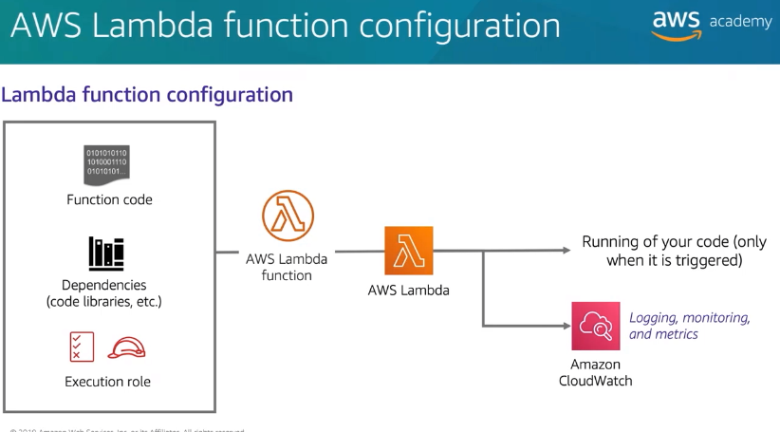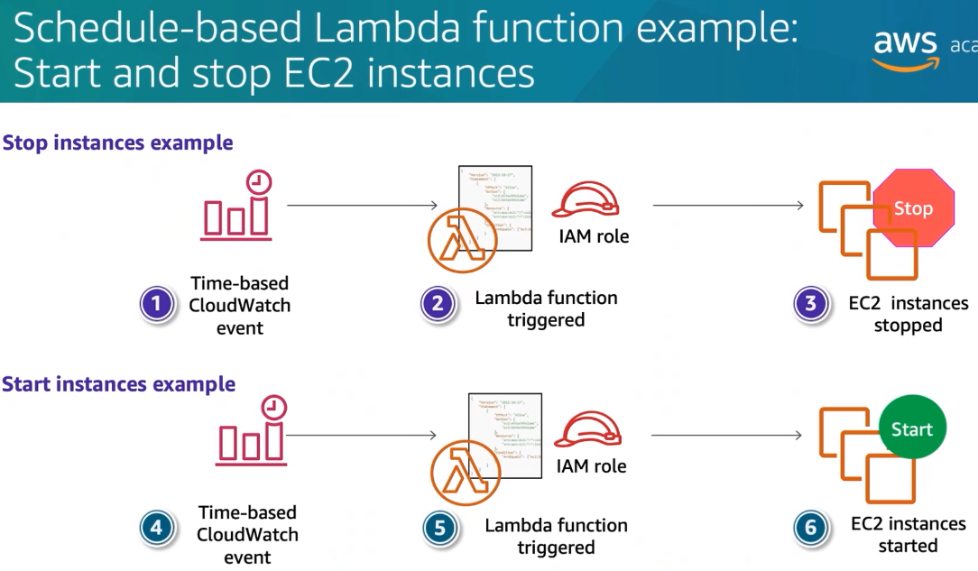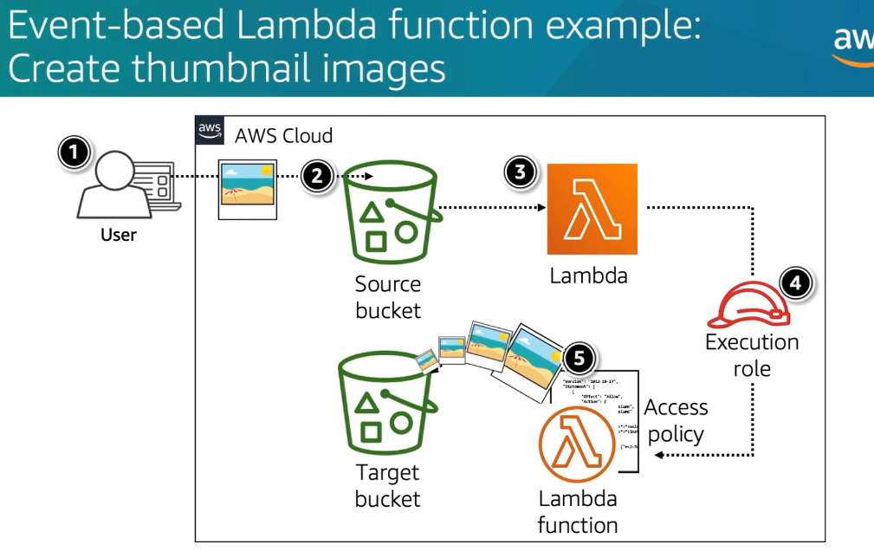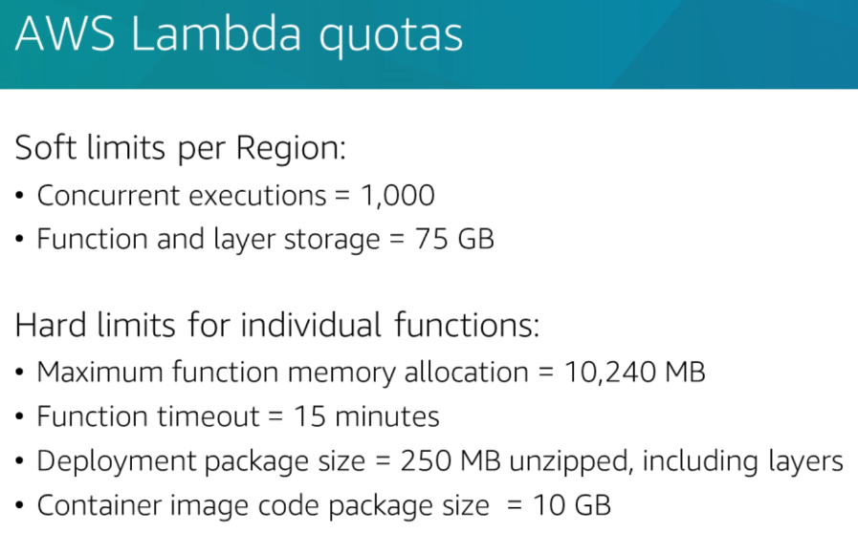

6.AWS Elastic Beanstalk

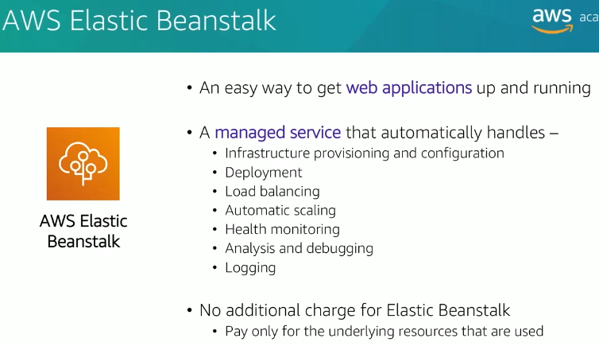

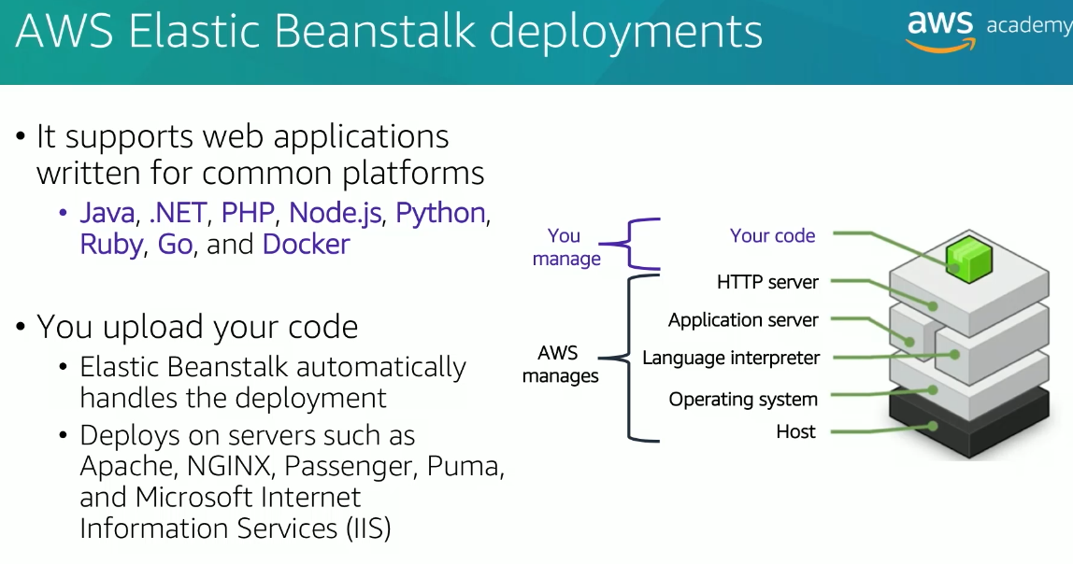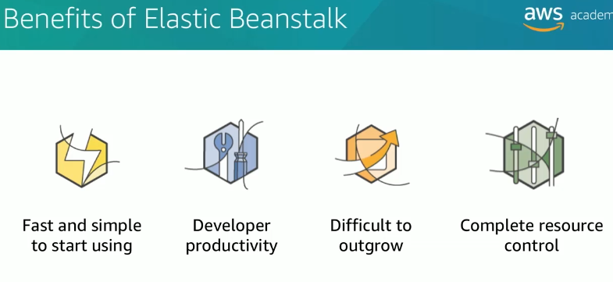

Module -7

STORAGES

Topics

. Amazon Elastic Block Store (Amazon

EBS)

· Amazon Simple Storage Service

(Amazon S3)

. Amazon Elastic File System (Amazon

EFS)

· Amazon Simple Storage Service

Glacier

1.Amazon EBS

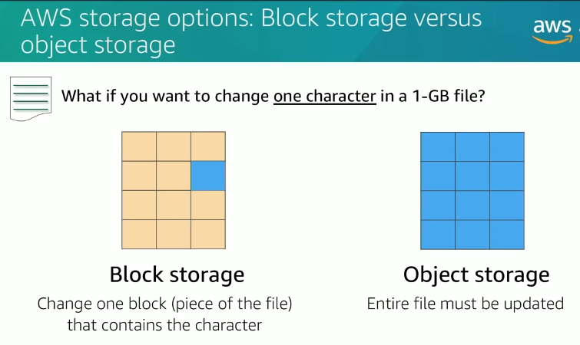

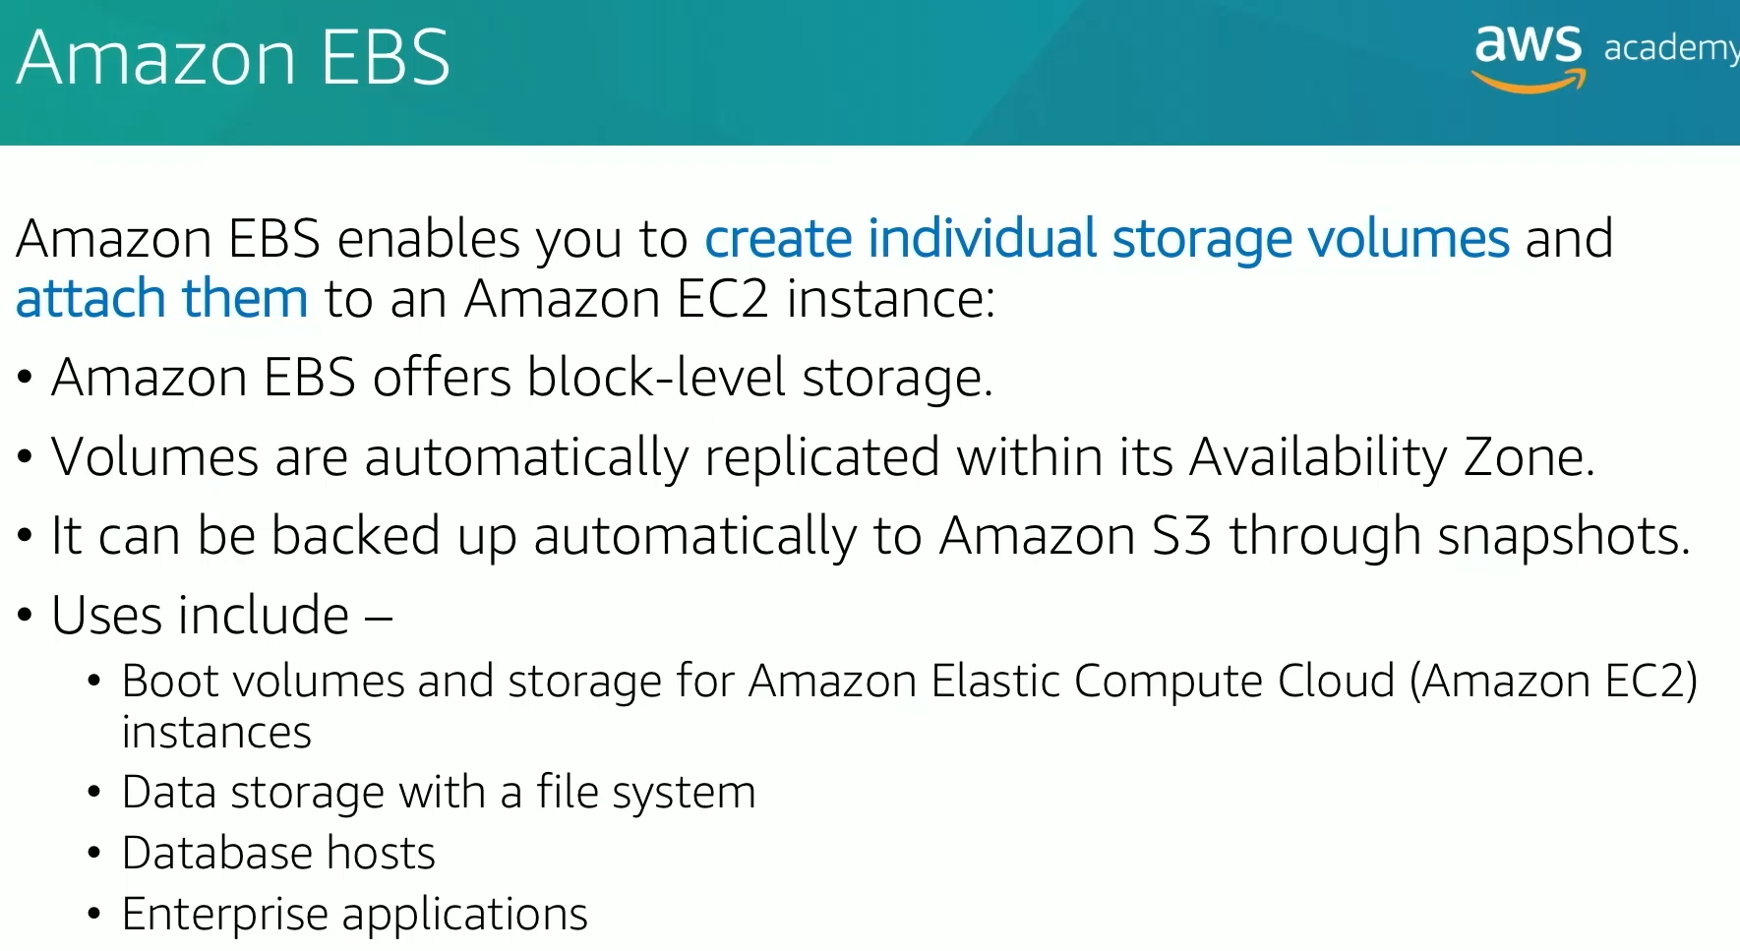 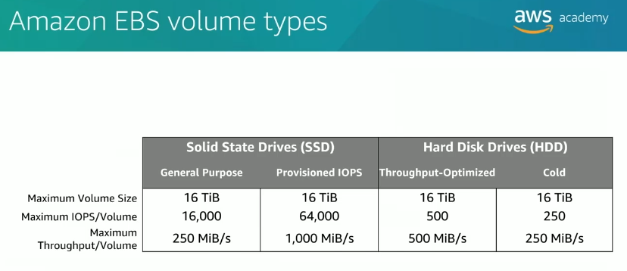 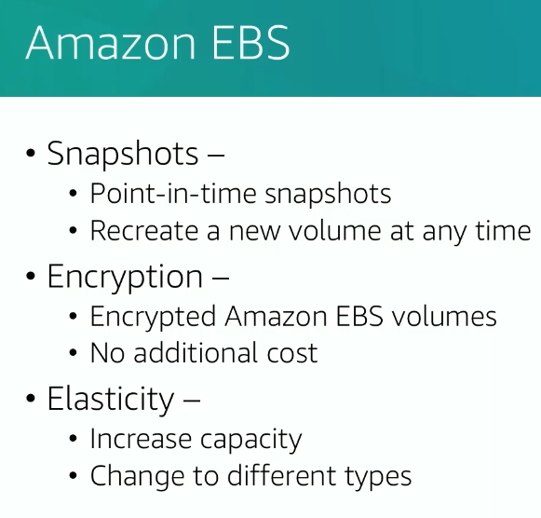 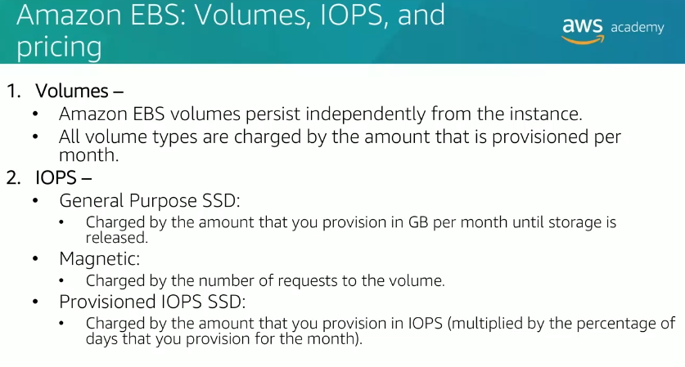 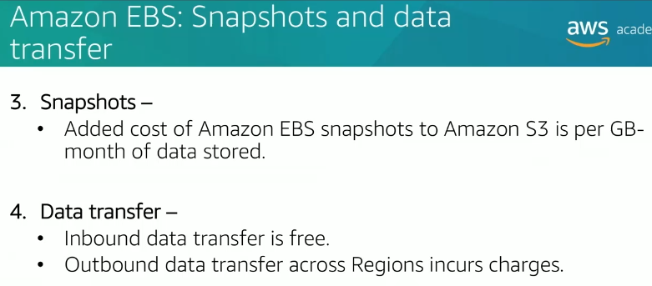

2.Amazon S3

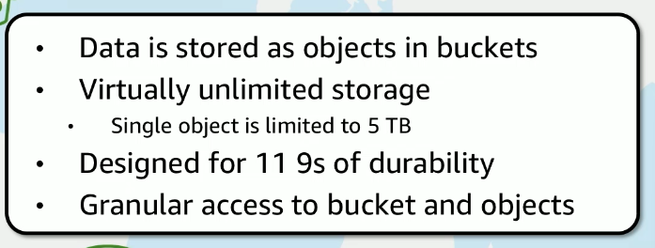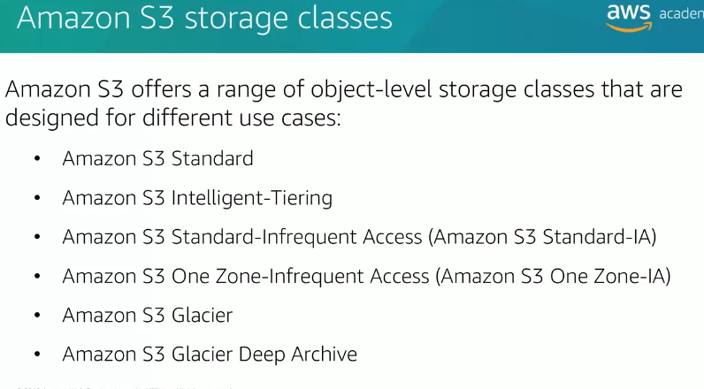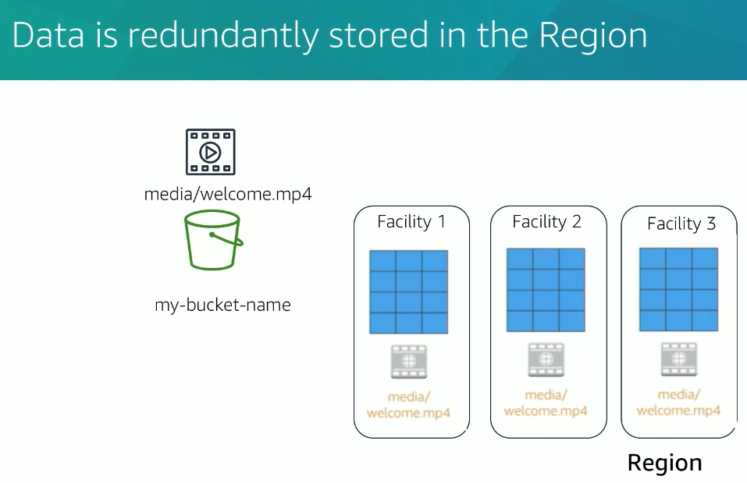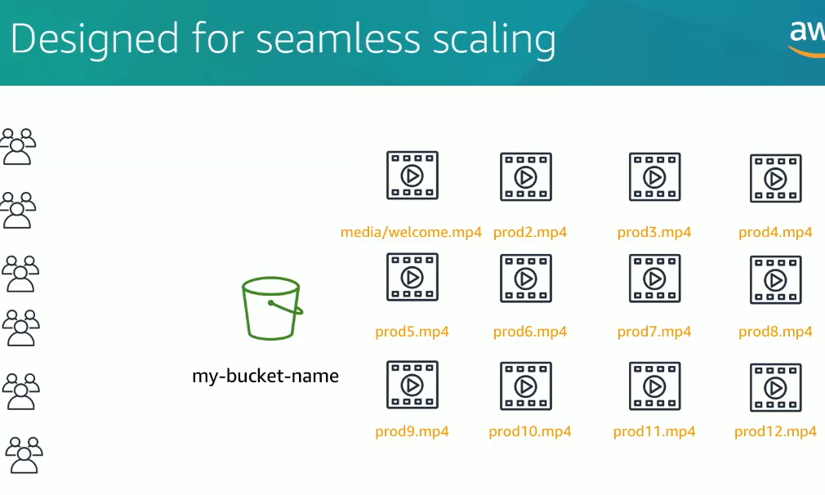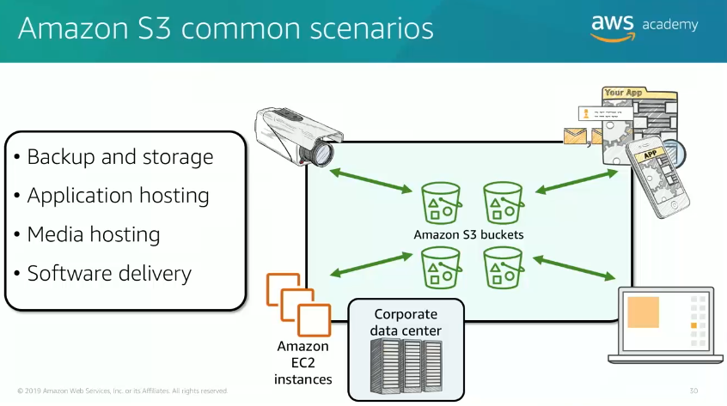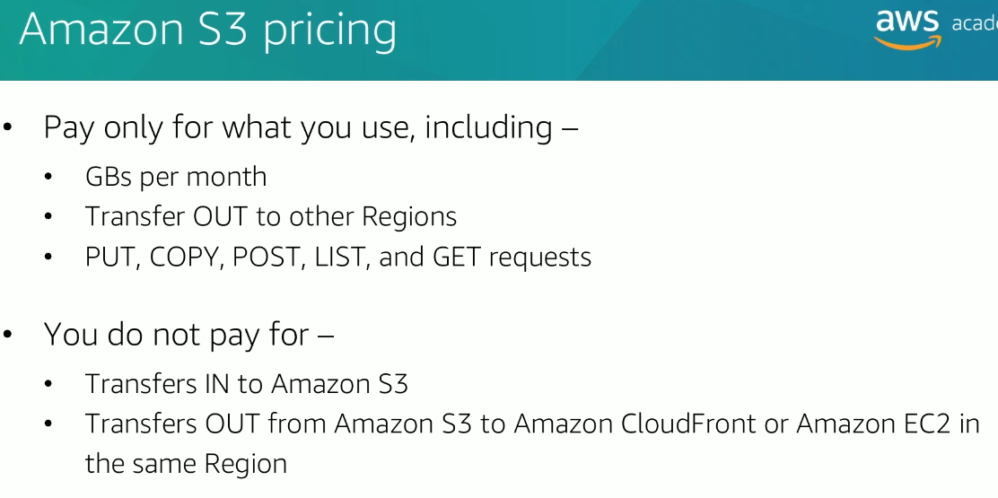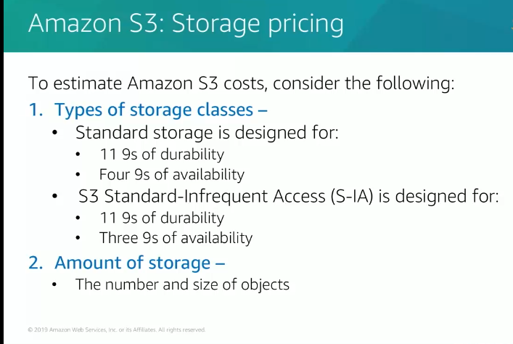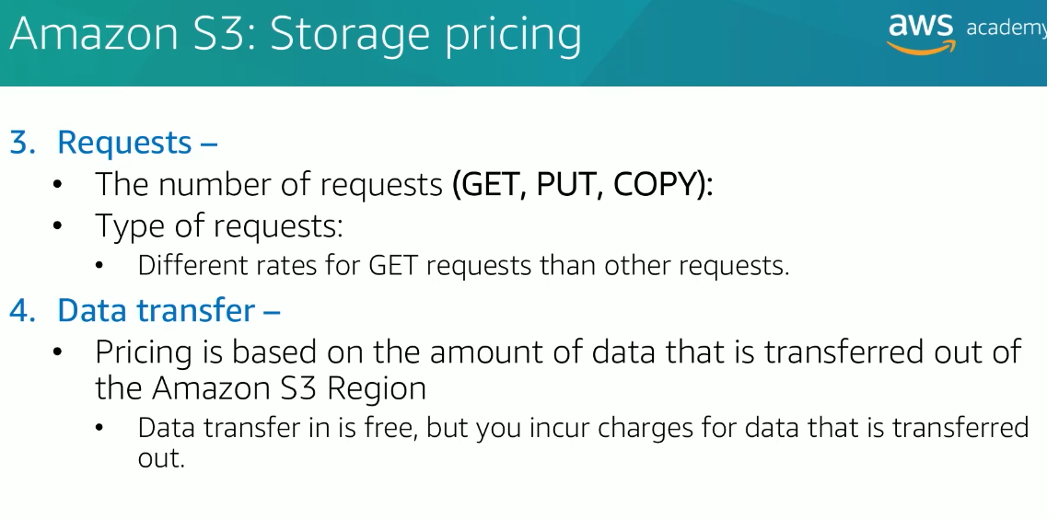

**3.EFS**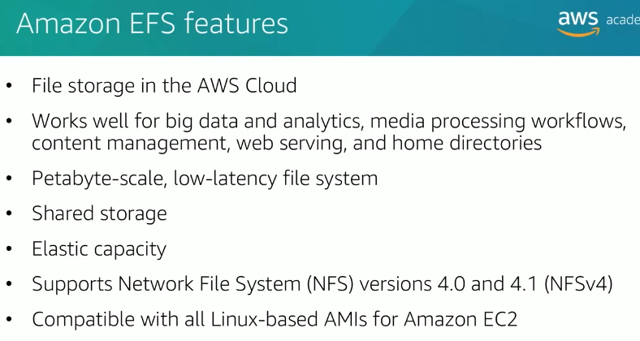

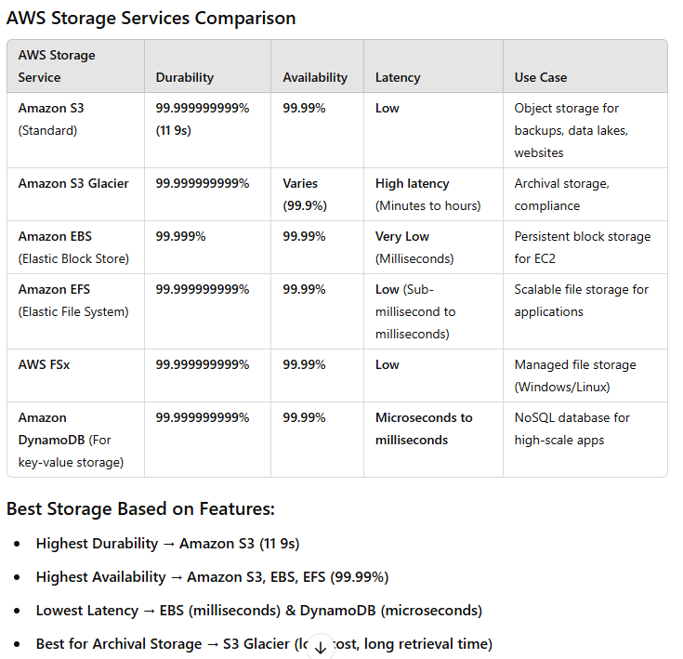

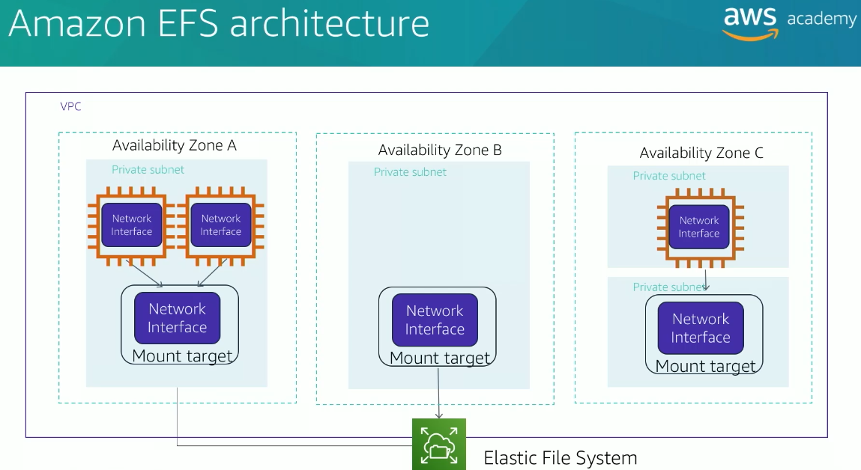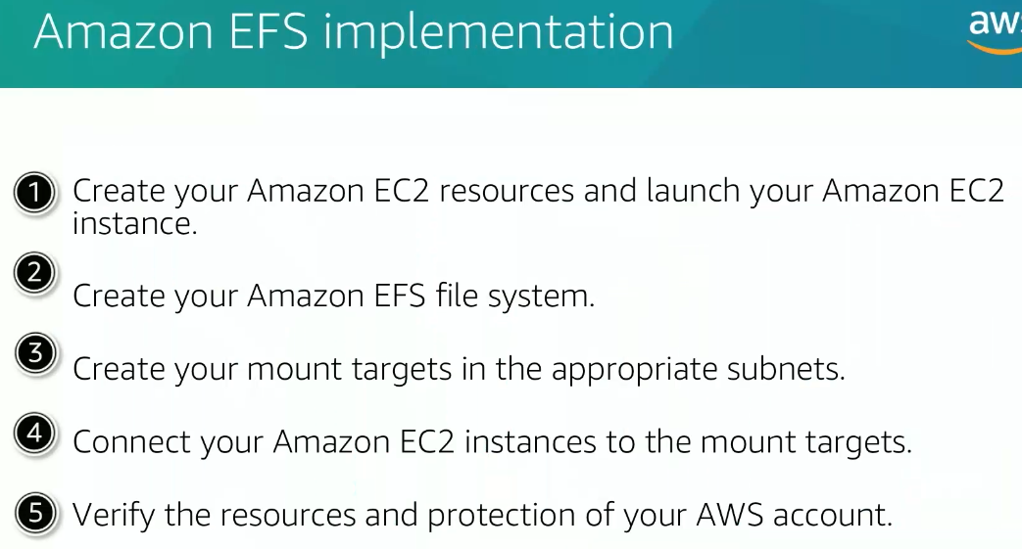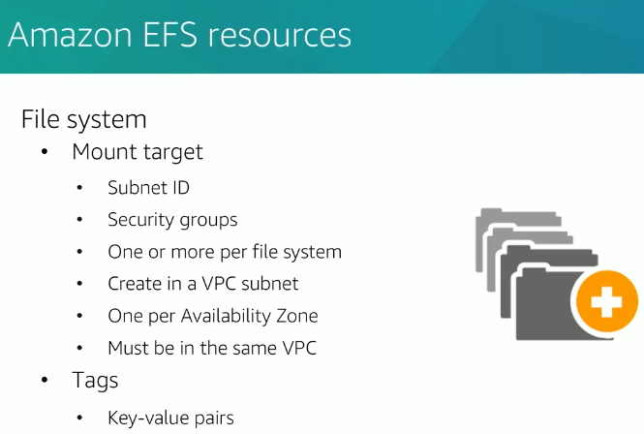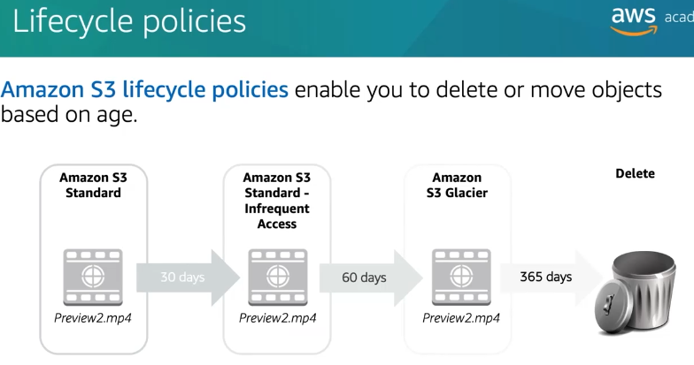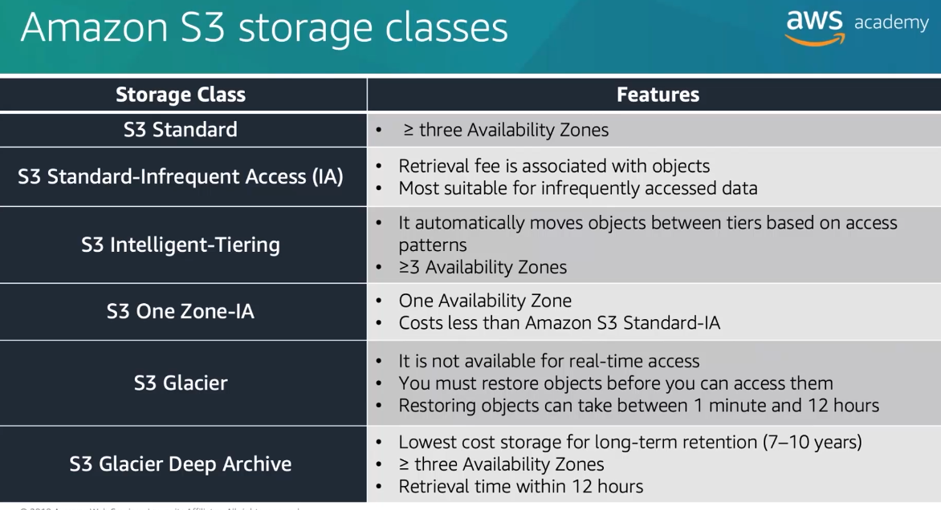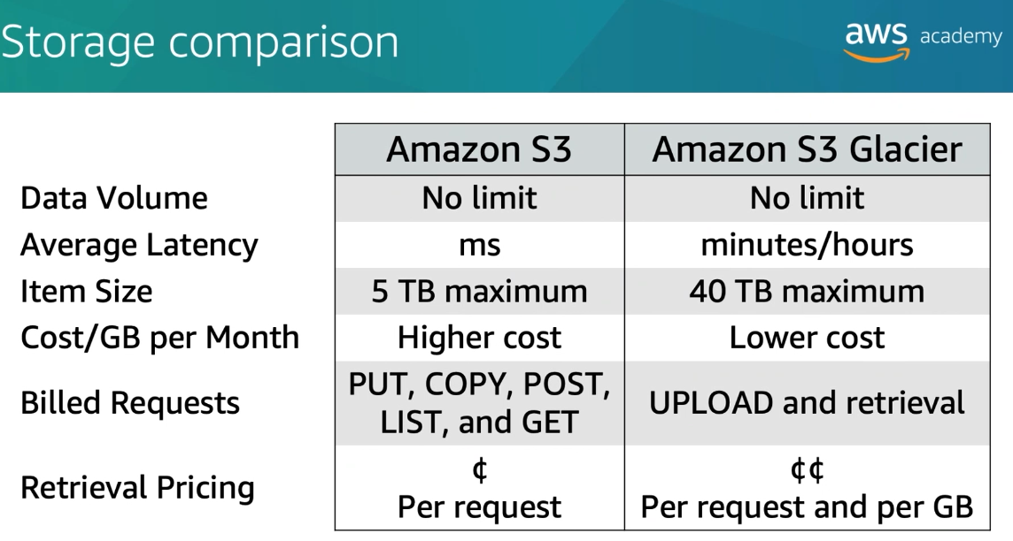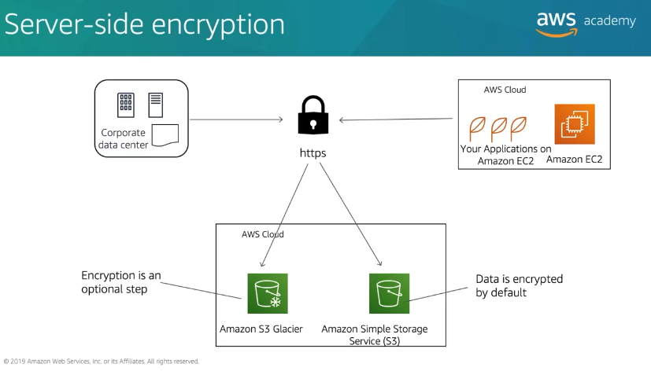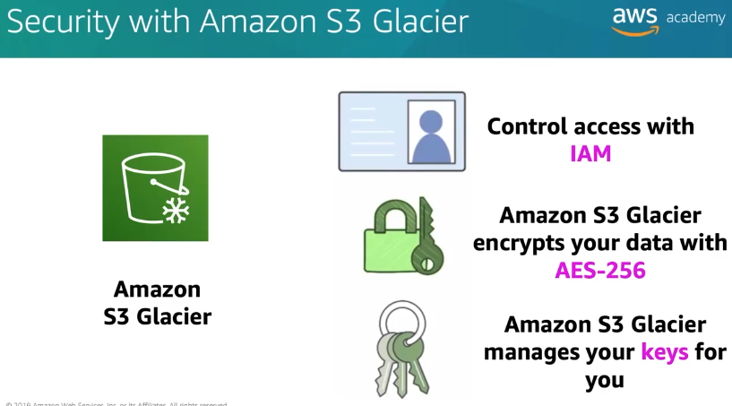

Module -8

DATABASES

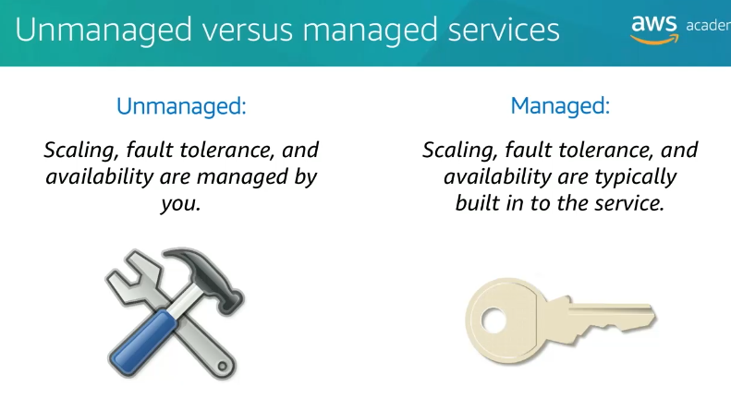 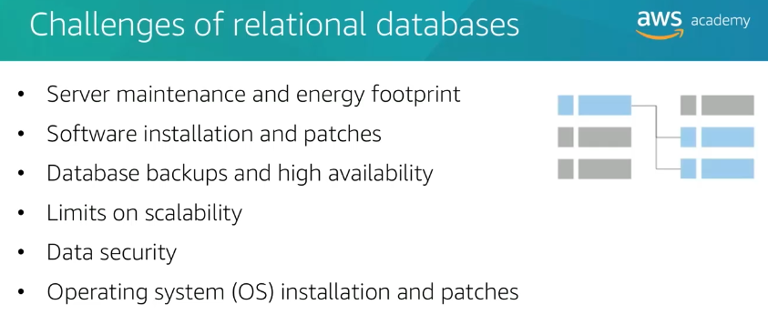 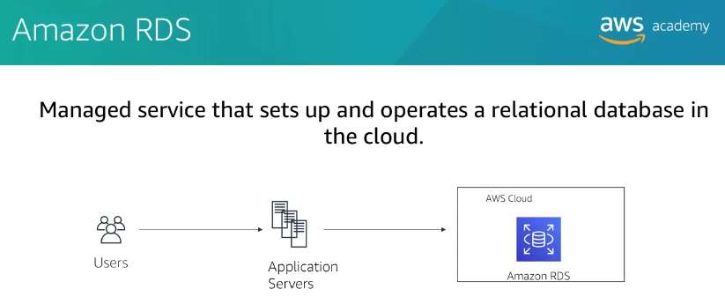 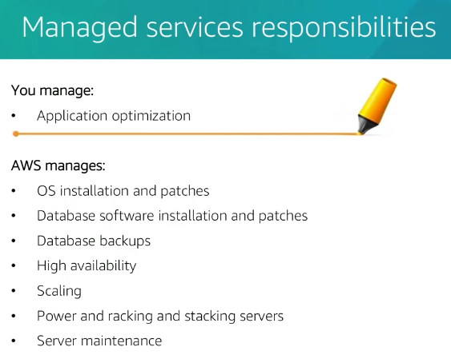 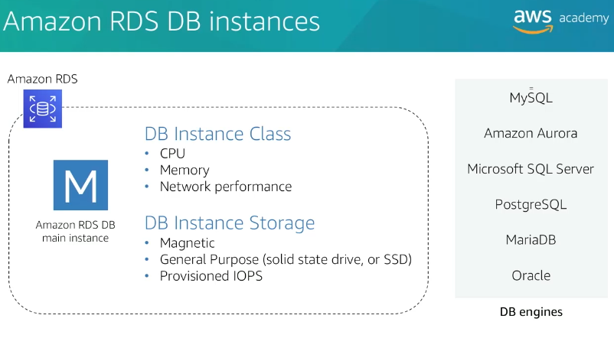 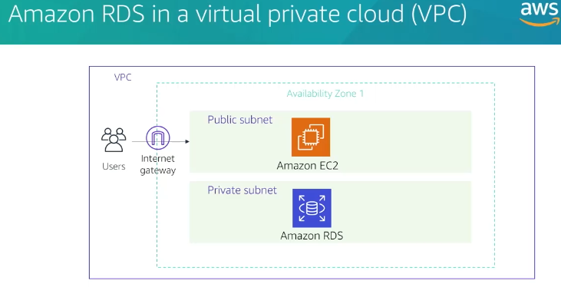 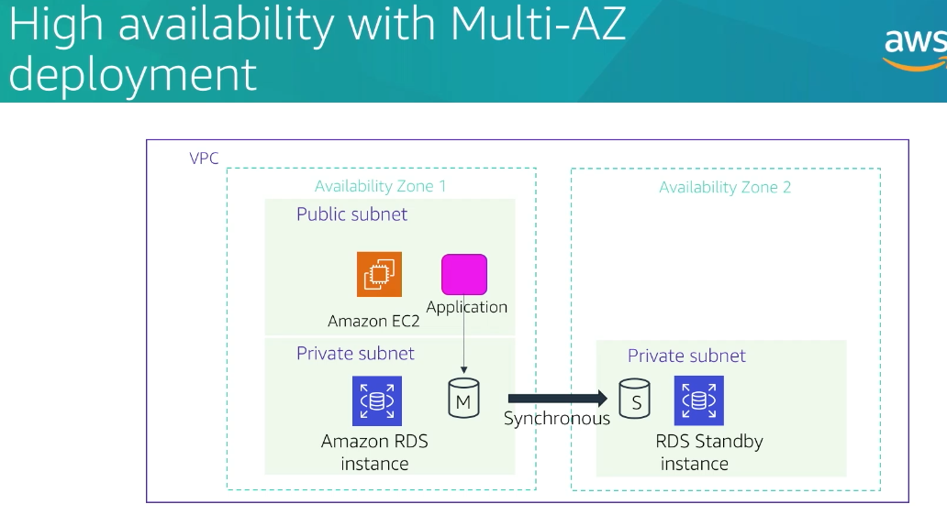 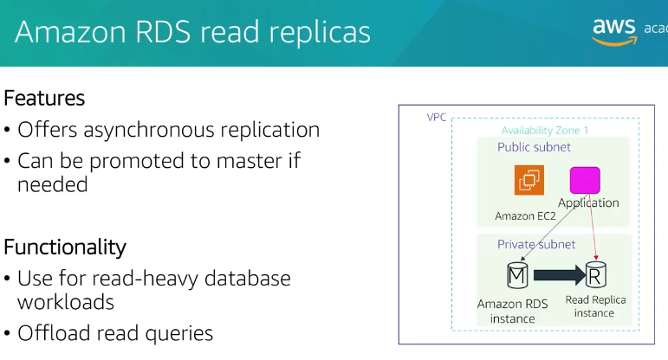 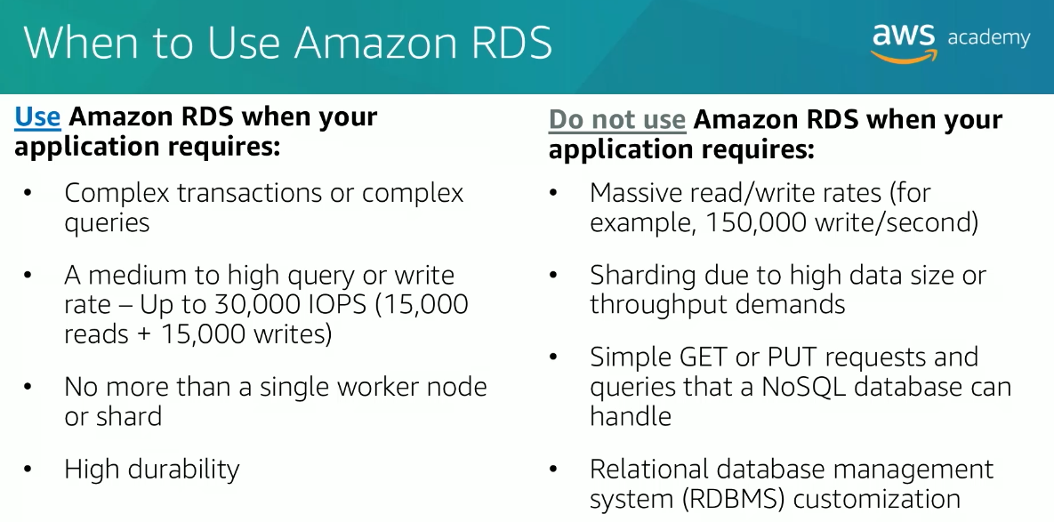

2. Amazon DynamoDB

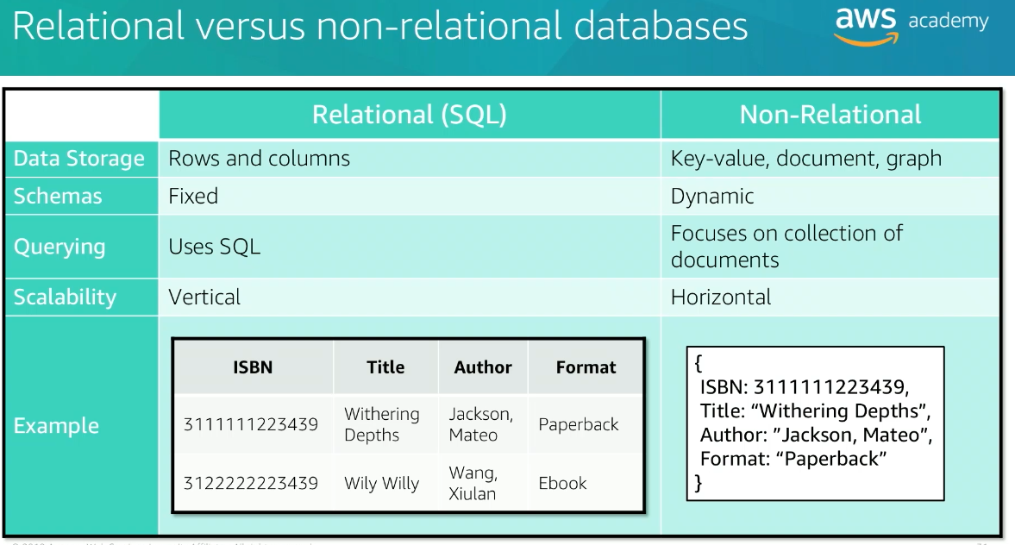 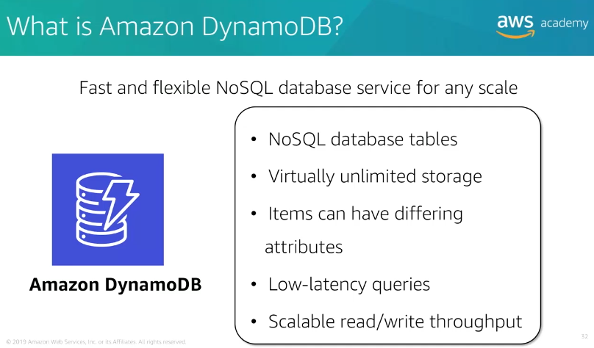 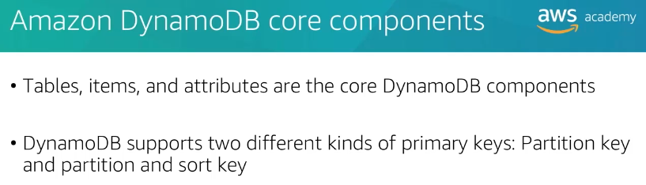 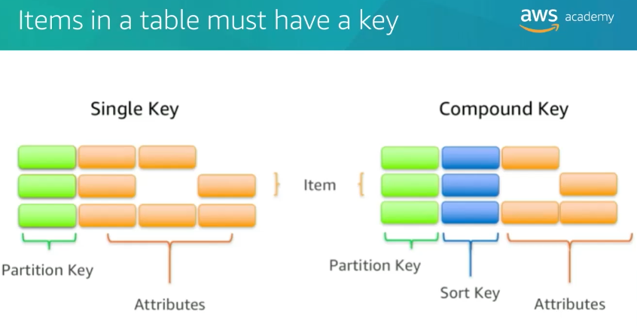

**3**.**Amazon Redshift**

Analytics is important for businesses today, but building a data warehouse is complex and expensive. Data warehouses cantake months and significant financial resources to set up.Amazon Redshift is a fast and powerful, fullymanaged data warehouse that is simple and cost-effective to set up, use, and scale. It enables you to run complex analytic queries against petabytes of structured data by using sophisticated query optimization, columnar storage on high-performance local disks, and massively parallel data processing. Most results come back in seconds.

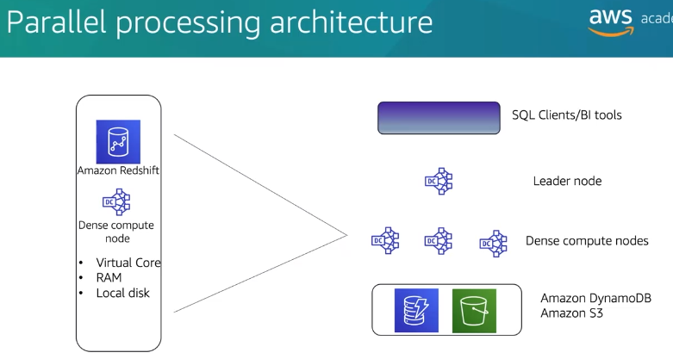 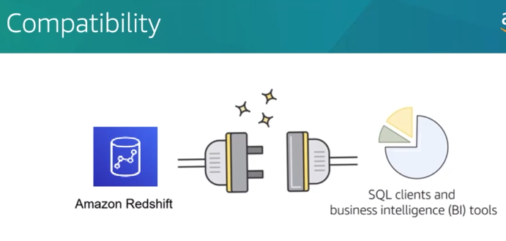 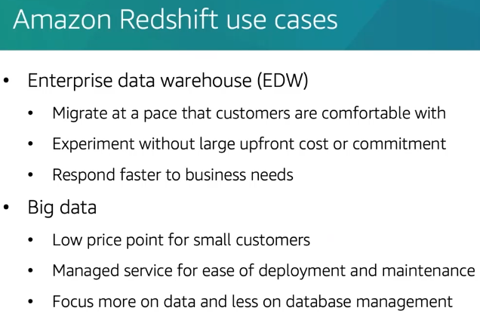 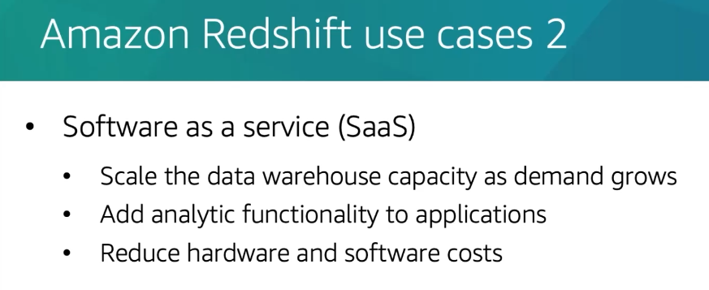

1. Amazon Aurora

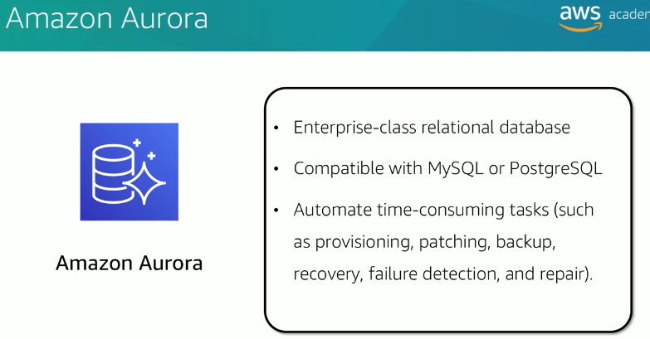 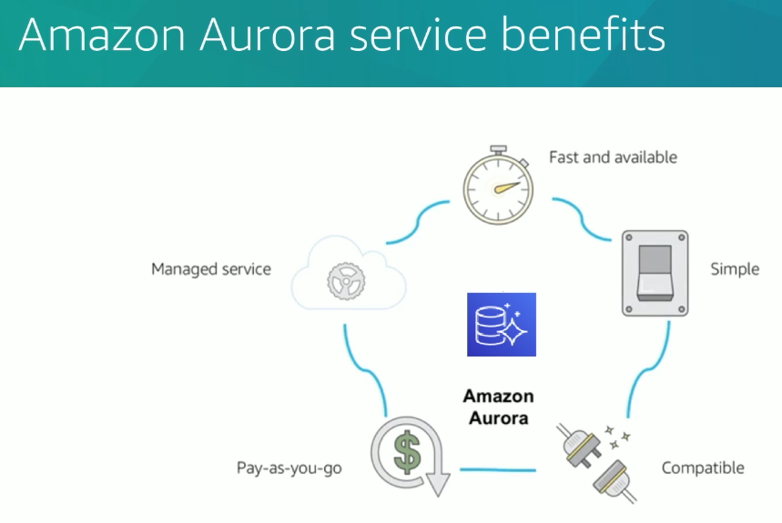 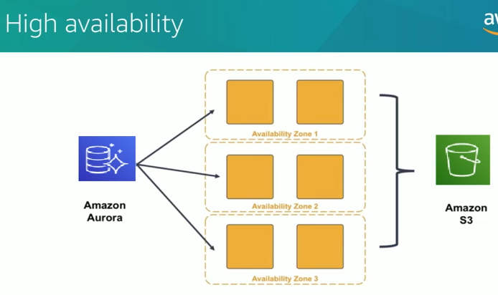 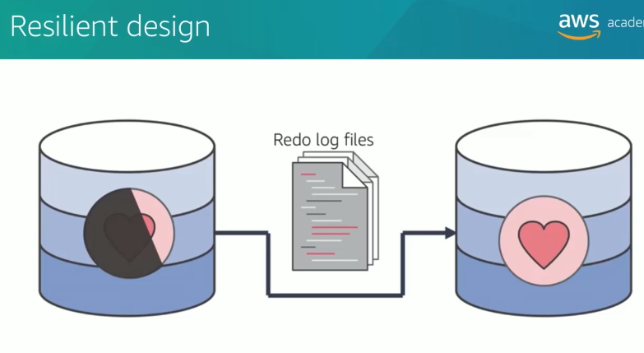

Module -9

CLOUD ARCHITECTURE

1. **AWS Well-Architected Framework Design Principles**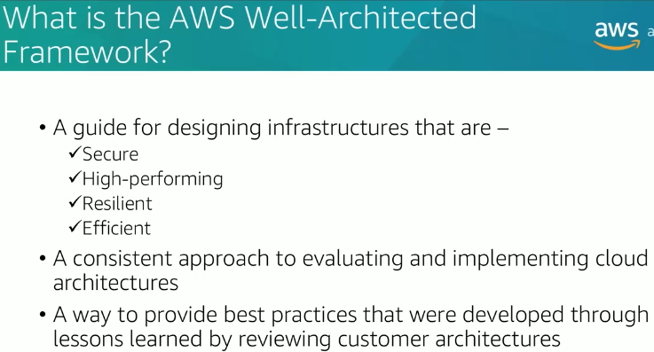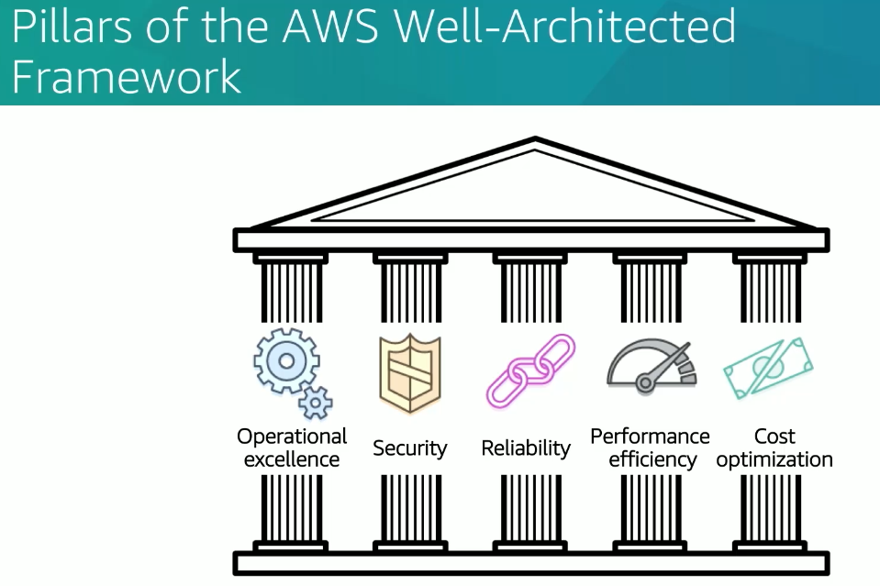

**Perform operations as code --> Operational Excellence**

**Enable traceability --> Security**

**Automatically scale to meet demand --> Reliability**

**Deploy resources globally to improve response time --> Performance Efficiency**

**Automatically recover from failure --> Reliability**

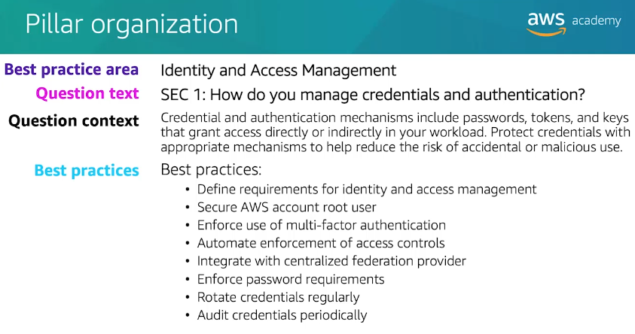

**Pillars of the AWS Well-Architected Framework**

The AWS Well-Architected Framework consists of **five key pillars** that help organizations design reliable, secure, efficient, and cost-effective cloud architectures.

**1. Operational Excellence**

* Focuses on running and monitoring systems efficiently to deliver business value.
* Involves **automation, monitoring, and continuous improvement** of processes.
* Uses **infrastructure as code (IaC)** and **automated deployments** for efficient operations.
* AWS Services: **AWS CloudFormation, AWS Config, AWS Systems Manager, AWS X-Ray**.

**2. Security**

* Ensures **protection of data, systems, and assets** using security best practices.
* Covers areas like **data encryption, access control, and compliance**.
* Implements **least privilege access**, logging, and threat detection.
* AWS Services: **AWS IAM, AWS Shield, AWS KMS, AWS WAF, AWS Security Hub**.

**3. Reliability**

* Ensures a system can **recover from failures and continue functioning**.
* Involves **automated recovery, failover mechanisms, and distributed architectures**.
* Uses **scalability, backups, and replication** to maintain reliability.
* AWS Services: **AWS Auto Scaling, AWS Route 53, Amazon S3, AWS Backup, Amazon RDS Multi-AZ**.

**4. Performance Efficiency**

* Focuses on **optimizing resources** to maintain efficiency as demand changes.
* Uses **serverless architectures, caching, and auto-scaling** for performance improvements.
* Implements **load balancing and efficient database queries**.
* AWS Services: **AWS Lambda, Amazon CloudFront, Amazon DynamoDB, AWS Auto Scaling, AWS Compute Optimizer**.

**5. Cost Optimization**

* Helps manage and reduce costs **without compromising performance**.
* Uses **pay-as-you-go pricing models, reserved instances, and auto-scaling**.
* Regularly reviews **resource utilization and eliminates waste**.
* AWS Services: **AWS Cost Explorer, AWS Budgets, Amazon EC2 Spot Instances, AWS Savings Plans**.

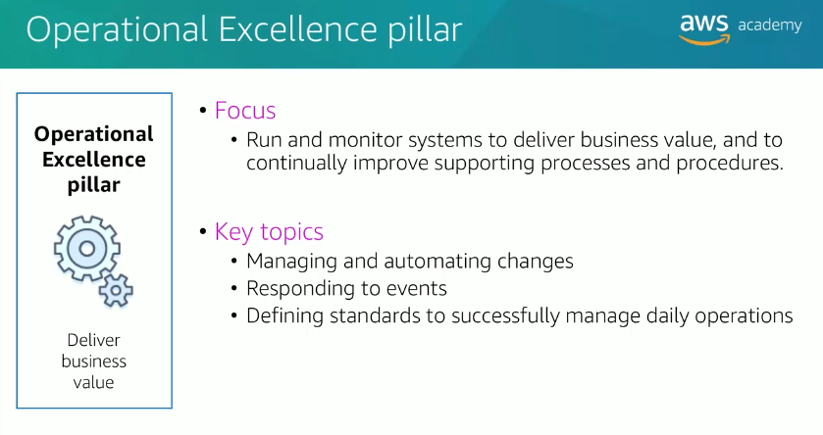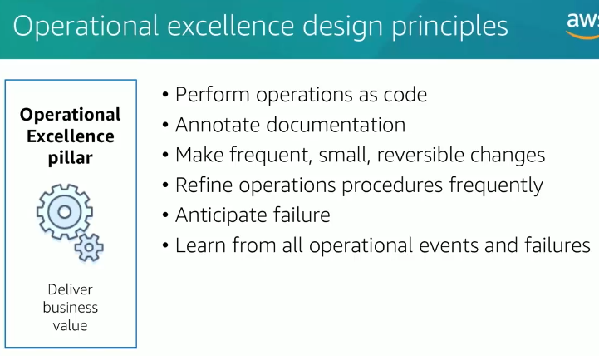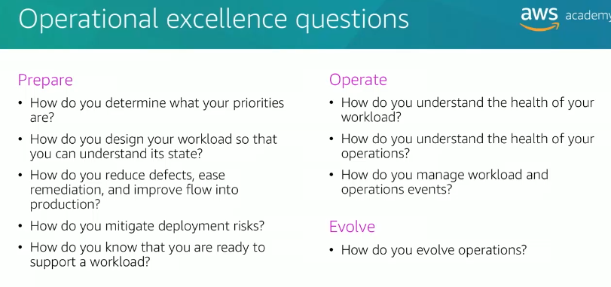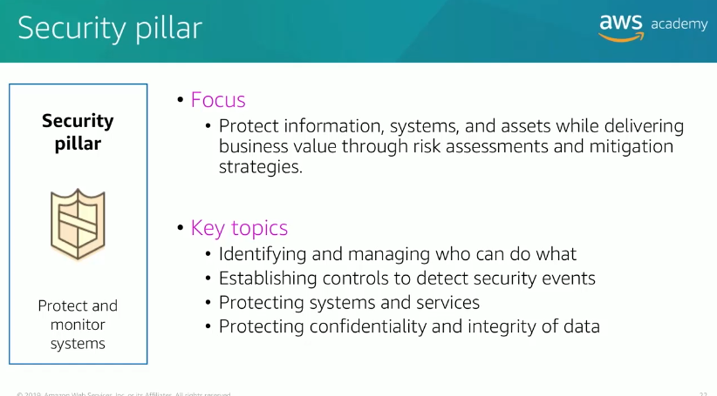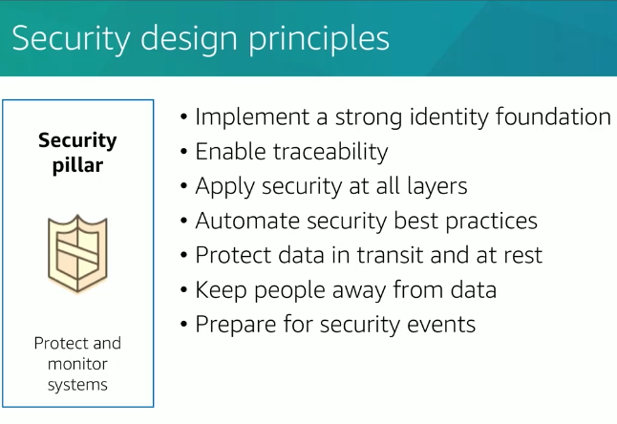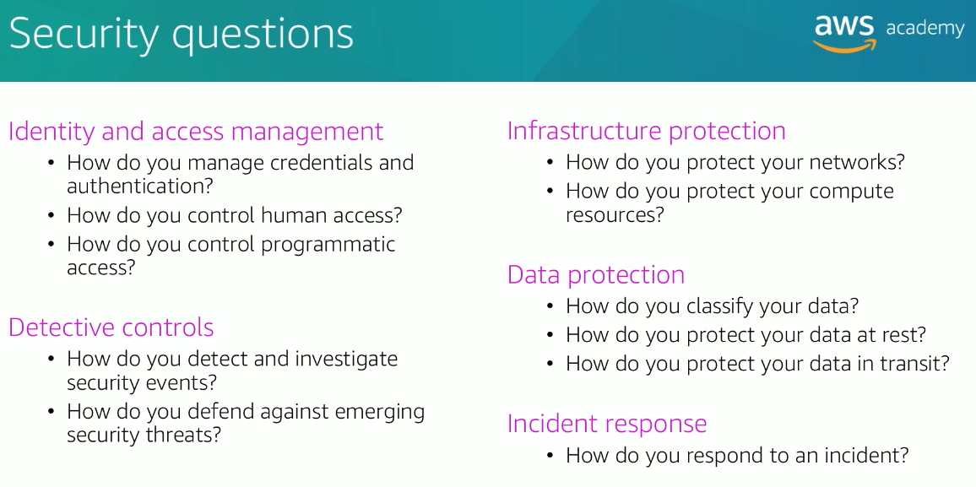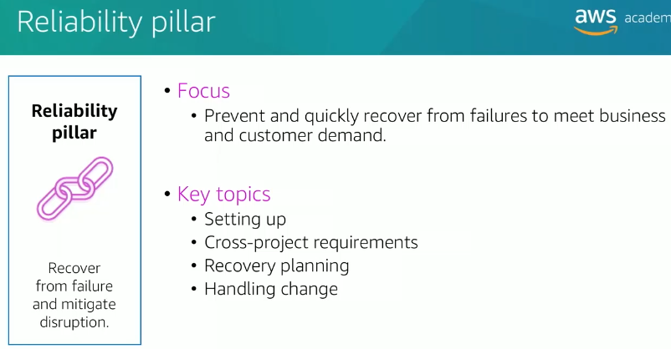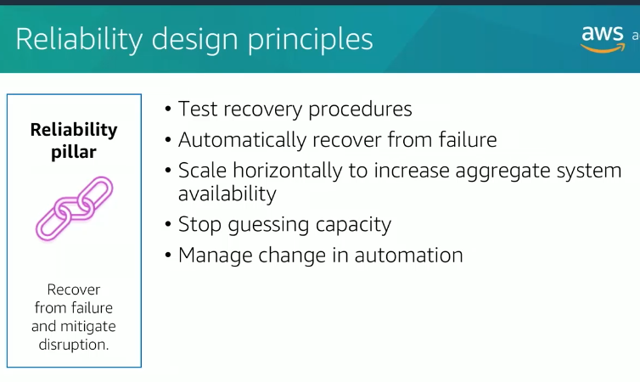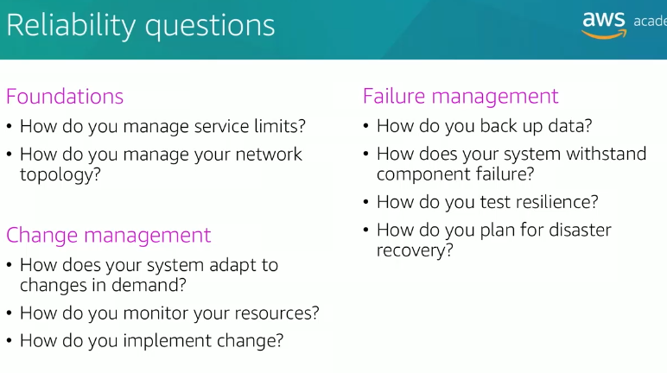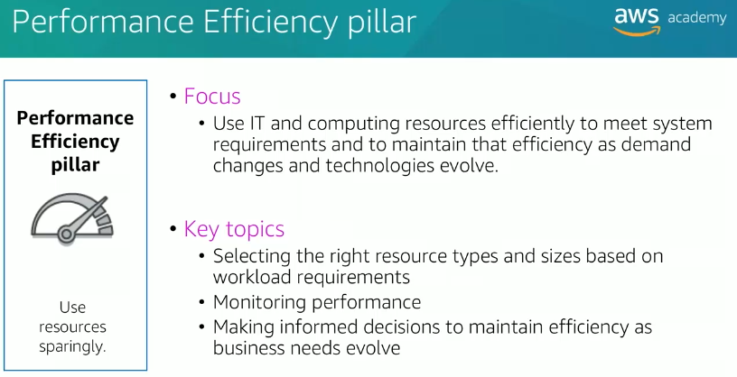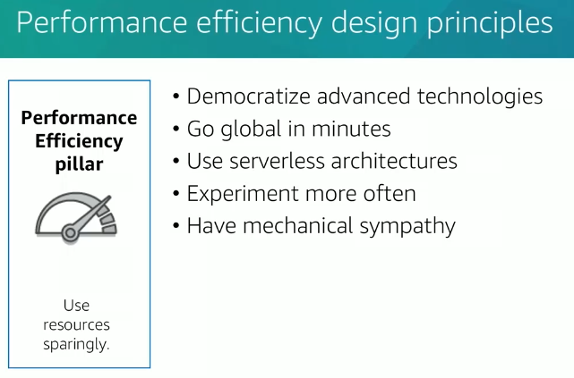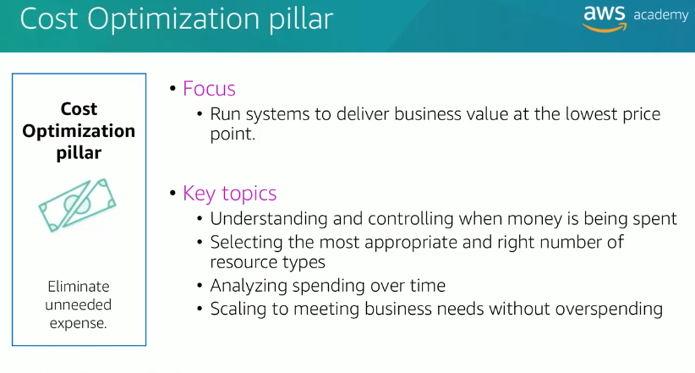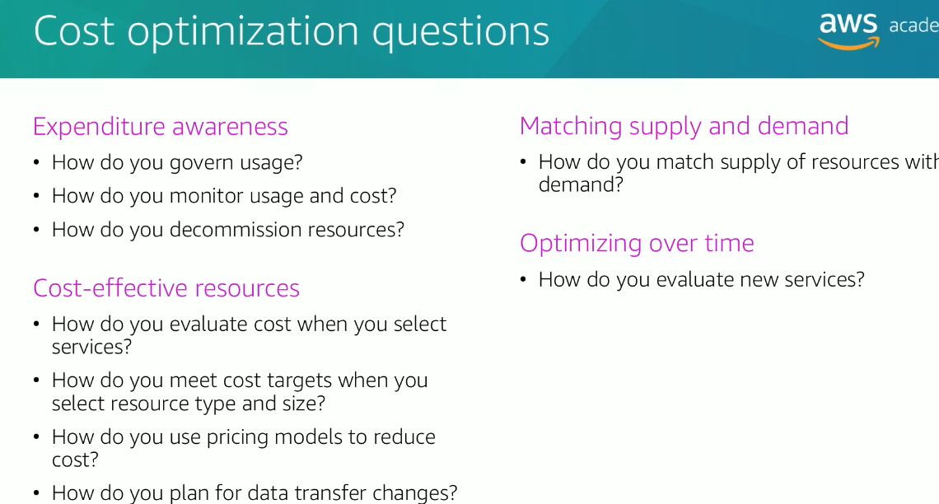

**2.Relability and Availability:**

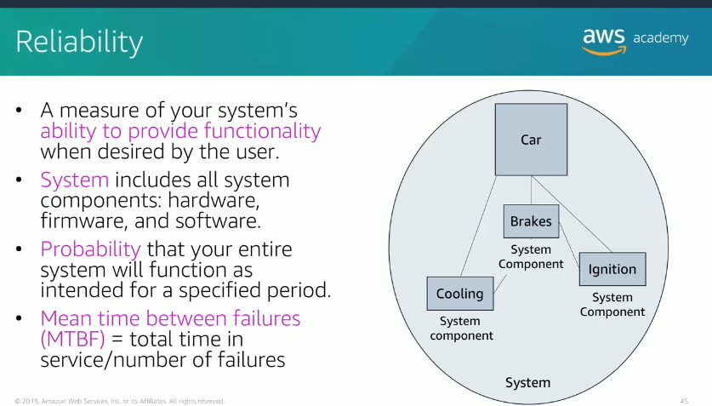

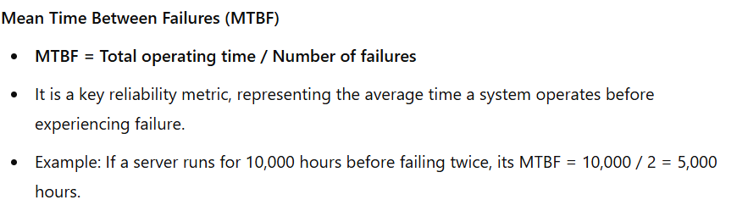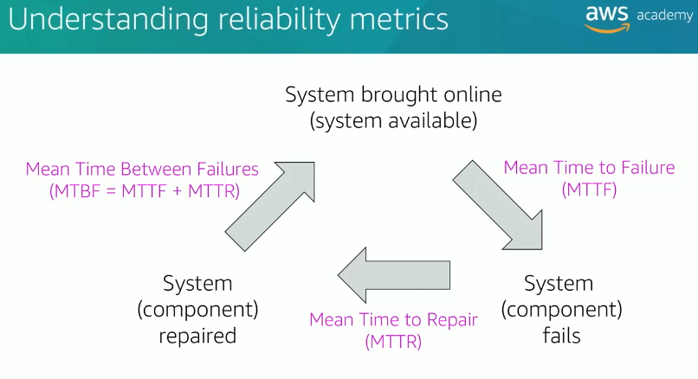

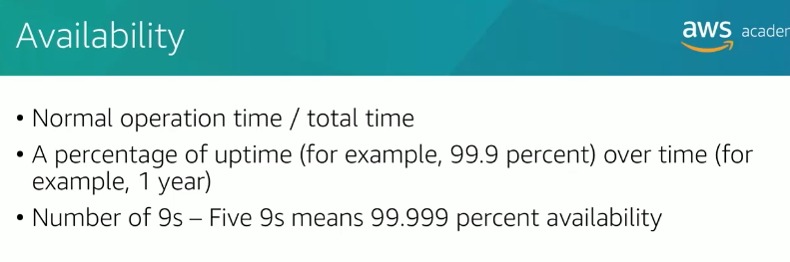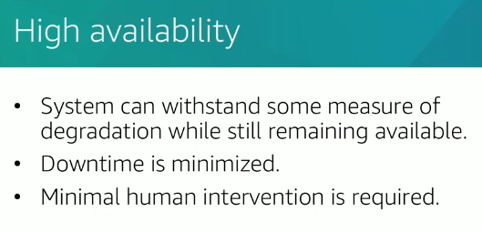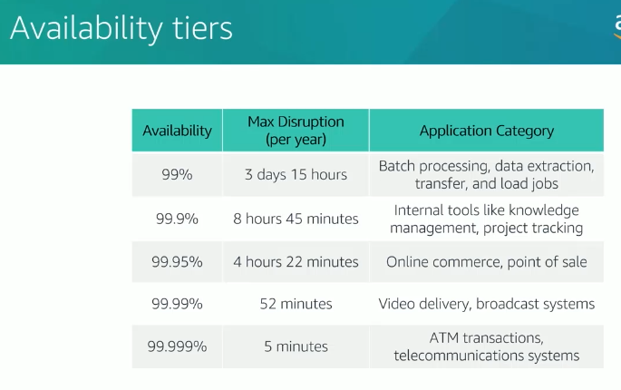

The **"Max Disruption per year"** in the image refers to the **maximum allowable downtime** a system or service can experience in a year while maintaining a specific availability percentage.

**Breakdown:**

* **99% availability** means the system can be down for up to **3 days and 15 hours** in a year.
* **99.9% availability (Three Nines)** allows **8 hours and 45 minutes** of downtime annually.
* **99.99% availability (Four Nines)** reduces downtime to **52 minutes** per year.
* **99.999% availability (Five Nines)** limits downtime to just **5 minutes** per year, which is crucial for mission-critical applications like **ATM transactions and telecom systems**.

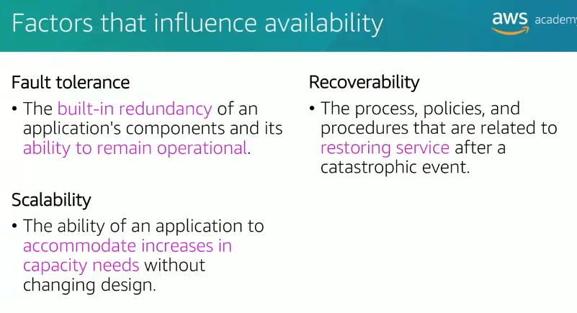

**3.AWS Trusted Advisor**

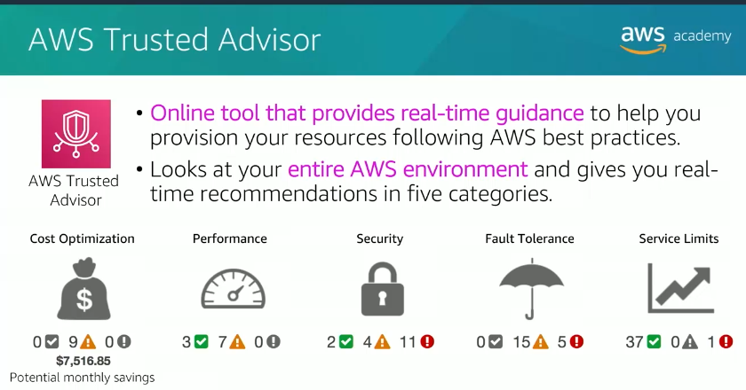

Module 10

AUTO SCALING AND MONITORING

Topics

1.Elastic Load Balancing

2.Amazon CloudWatch

3. Amazon EC2 Auto Scaling

1.Elastic Load Balancing

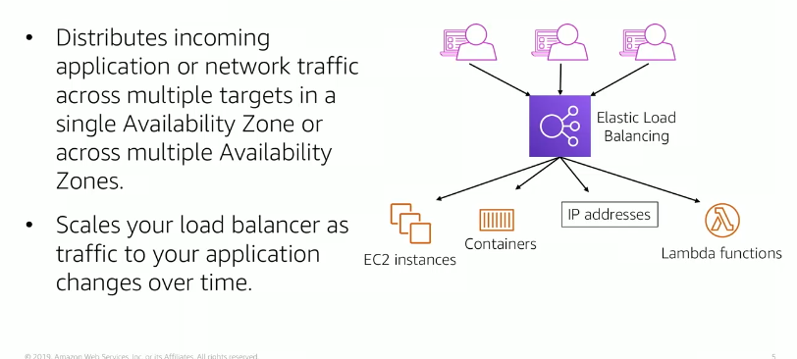

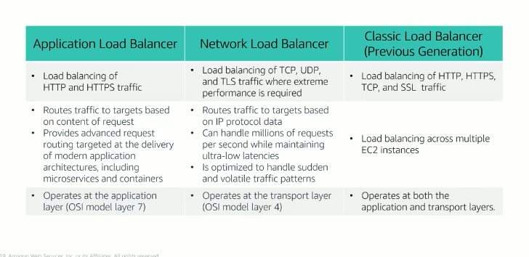

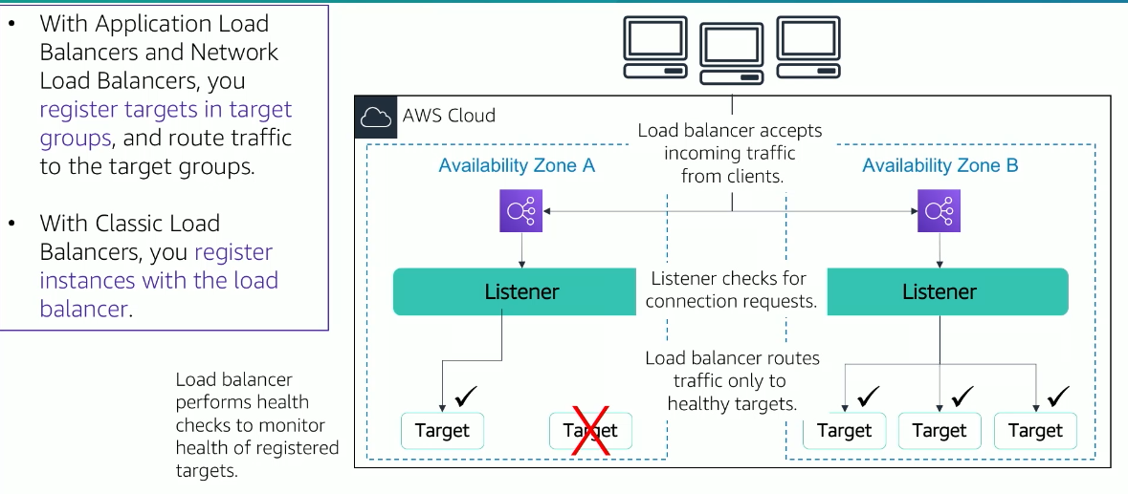

2.Amazon CloudWatch

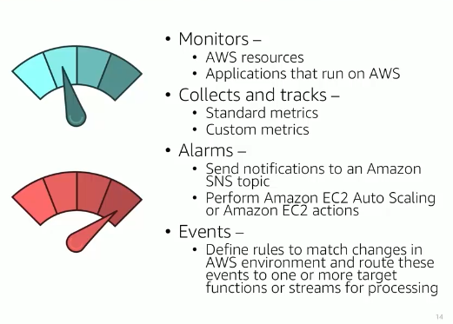

Amazon CloudWatch is a comprehensive monitoring and observability service provided by AWS (Amazon Web Services) for cloud resources and applications. It allows you to collect, monitor, and analyze data in real-time from AWS resources and on-premises systems. Here's a breakdown of its features and uses:

**Key Features:**

1. **Metrics Collection**:
   * CloudWatch collects metrics from AWS services like EC2, RDS, Lambda, S3, and custom metrics from your applications.
   * Metrics are aggregated, providing insights into performance, utilization, and operational health.
2. **Logs Monitoring**:
   * You can use CloudWatch Logs to monitor, store, and access log files from AWS resources and custom sources.
   * It supports real-time log analysis for debugging and troubleshooting.
3. **Dashboards**:
   * CloudWatch allows you to create customizable dashboards to visualize metrics and logs in a single view.
   * Dashboards can include graphs, widgets, and alerts for operational monitoring.
4. **Alarms**:
   * CloudWatch Alarms notify you when specific thresholds for metrics are breached.
   * Alarms can trigger automated actions, such as scaling EC2 instances or invoking an AWS Lambda function.
5. **Events**:
   * With CloudWatch Events (now part of Amazon EventBridge), you can respond to changes in your AWS environment, such as resource state changes or specific API calls.
6. **Application Insights**:
   * Helps you monitor and troubleshoot applications by identifying and diagnosing performance issues or faults.
7. **Logs Insights**:
   * Provides a powerful query language for analyzing and querying log data.

**Use Cases:**

1. **Performance Monitoring**:
   * Track CPU, memory, and disk usage for EC2 instances.
   * Monitor request latency and throughput for APIs.
2. **Operational Insights**:
   * Detect resource under-utilization or over-utilization.
   * Monitor application logs for errors or anomalies.
3. **Automation**:
   * Automatically scale infrastructure based on usage.
   * Trigger recovery actions in case of failures.
4. **Compliance and Security**:
   * Monitor access and activities in your AWS account.
   * Identify and respond to unauthorized access attempts.
5. **Custom Applications Monitoring**:
   * Send custom metrics from your applications to CloudWatch for tailored monitoring.

**Pricing:**

Amazon CloudWatch uses a pay-as-you-go pricing model. Costs are determined by:

* The number of metrics and alarms you monitor.
* The amount of log data ingested, archived, and analyzed.
* The retention period for logs.

CloudWatch is a vital tool for maintaining the health, performance, and availability of your AWS workloads. It integrates seamlessly with other AWS services and offers the flexibility to support a wide range of monitoring and alerting scenarios.

3. AWS EC2 Auto Scaling

